The Black

Pear Bulletin

*The Newsletter of the Battle of Worcester Society*

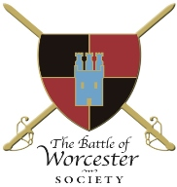

**Issue No. 14 ~ Summer Edition 2016**

**OUR CHAIRMAN WRITES**

Welcome to the Summer edition of the *Black Pear Bulletin* for 2016. We have many interesting events planned for the remainder of the year, details of which are included in the Bulletin.

**CHARLES RETURNS TO BOSCOBEL!**

Following the success of the Christmas Tree Festival in 2015 and subsequent display at The Commandery, our sculptor Ken Potts has installed his *Christmas at Boscobel* at Boscobel House in Shropshire. The tree will be displayed in the book store indefinitely.

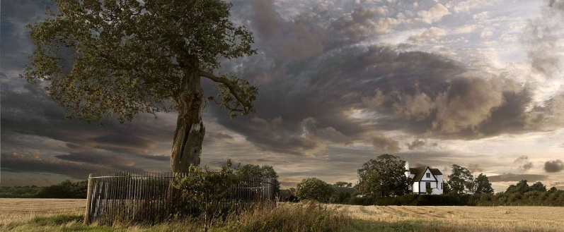 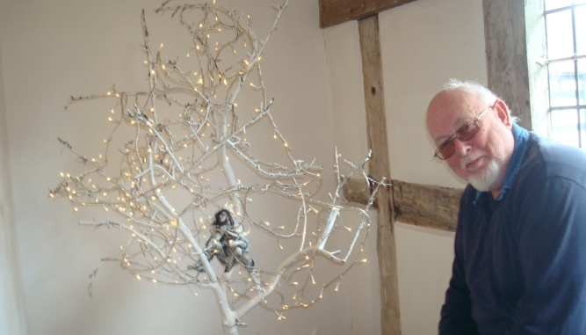

**CIVIL WAR NIGHTS**

I am delighted to let you know that our season of Civil War Talks started off with a bang! In April, Trustee Hannah (Worthen) Wilson presented us with a talk entitled '**Widows, Wives, Soldiers and Spies: the Lives of Women in the Civil Wars’ to** an audience of more than thirty, despite the heavy rain.Hannah included many examples of women’s experiences during the Battle of Worcester.

In May Dr John Miller, Professor of early modern history and a highly acclaimed historian of the English Civil Wars argued that '**Charles 1 Loser or Winner'** gained support although he was defeated militarily his ‘martyrdom’ greatly strengthened the ideological and emotional foundations of the monarchy.

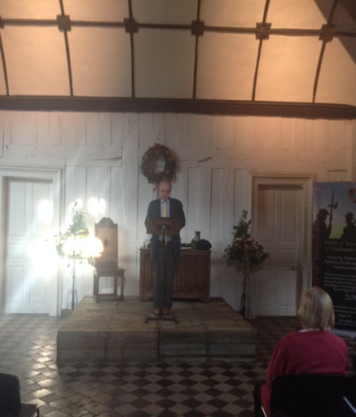

Dr Blair Worden Emeritus Fellow of St Edmund’s Hall, University of Oxford and author of many books on Civil War issues, entertained us in June with his paper on **Oliver Cromwell**. The Great Hall at The Commandery was still decorated following the marking of Oak Apple Day the previous weekend. It gave the hall a periodic feel and the sun was very welcome!

Later in June, with the audience now growing to fifty, a **'Quacks, Butchers or Pioneers - Surgeons and the Treatment of Wounds in the Civil Wars'** talk byDr Stephen Rutherford of Cardiff University showed how devastating a sword injury could be when he demonstrated sword cuts on a joint of pork which was suspended from a splendid Heath Robinson contraption. Dr Rutherford’s presentation showed that over time surgical instruments had changed very little in shape and that even now we use some treatments that were used in the seventeenth century. Many of the examples cited by Dr Rutherford were from the writings of Richard Wiseman, a key surgeon during the Civil War, later Sergeant Surgeon to Charles II who was present at the Battle of Worcester in 1651.

We look forward to our final talk in this season of talks, **The Royalist Highwayman** which will be held on Thursday 1st September, in The Great Hall, The Commandery given by Canadian Historical Novelist Cryssa Bazos, who has a particular interest in the seventeenth century and the English Civil Wars. She will present the true story of Captain James Hind who fought at the Battle of Worcester, escaped to London but was eventually arrested and the rest of the story makes for fascinating listening.

**THE COMMANDERY**

The proposed revamp of The Commandery Museum as a Civil War themed centre has got the go ahead. Our Chairman was invited to an unveiling of the plans for the refit which is hoped to be completed by the Spring of 2017.

**SITUATIONS VACANT**

We still have two official vacancies on the Executive Committee, Vice Chairman and Honorary Secretary. Their roles were described in the previous Bulletin. We would be delighted to hear from you if you are interested. However, if you would like to help but not take up a position of the Committee please let us know. For example, we always need extra help when we hold events to sell tickets, help out at the bar, set up electrical equipment, selling merchandise etc.

**SOCIAL OCCASIONS**

In our efforts to make all members feel part of the Society we listed a few ideas for social occasions. However we had practically no feedback regarding these ideas but will continue with our original suggestions and see if they work.

* A coach trip to Moseley Old Hall, Staffordshire where you can find out about the dramatic story of Charles Stuart who hid from Cromwell’s troops at Moseley Old Hall after he fled the Battle of Worcester in 1651. Here, you can see the bed on which the King slept and the priest hole in which he hid, and hear fascinating stories about what life was like in the 17th-century. You can soak up the atmosphere on one of their excellent guided tours. *We are proposing to run this trip in October half term, as it may be of interest to those of you with children or grandchildren*.
* A pie and a pint evening at King Charles’ House - As a wanted man with a price of £1000 on his head, Charles Stuart fled Worcester from what is now called **The King Charles House**, to France. This house has had many guises over the years but the new owners have now updated the building to restore it to its traditional style. *A provisional date has been set for this event –* ***6th October****, details to follow nearer the time.*
* Meet the Militia – Executive Committee Member and Worcester Re-enactor Brian Bullock has been instrumental in putting together the Worcester Militia, a new venture. The Militia will make an appearance in the procession from the Guildhall to the Commandery on 3 September 2016 as part of the Drumhead Service to commemorate the Battle of Worcester. Members will be able to meet the Militia in The Great Hall at The Commandery where there will be a 17th century bar but with 21st century prices!

**MONUMENT APPEAL**

Our work to progress the placing of the statue of John Adams and Thomas Jefferson in Fort Royal Hill Park continues.

The City Council has given permission for the monument to be placed in their park, subject to Planning Permission and Scheduled Monument Consent. A Planning Application was submitted on 13th June 2016 together with plans drawn up by Ken Potts. We are now awaiting a Structural Engineer’s report and the City Council Parks Department are dealing with the Scheduled Monument Consent application. We have had positive responses from all sides. The Friends of Fort Royal Park wondered if the statue could be floodlit, the Conservation Area Advisory Committee wanted it to be bigger than our plans and English Heritage may be able to make a donation towards the plinth.

**WORCESTER 370 - 2021**

We are looking towards a full scale Sealed Knot re-enactment to mark the 370th anniversary of the battle. We have made a provisional booking with the Sealed Knot and are "opening a dialogue" with the City Council to see if this can be achieved.

**MONARCH’S WAY**

Three intrepid runners attempted to run the whole of the Monarch’s Way. Unfortunately after four days of running all were completely done in! If you would like to enter next May, Challenge Running would be delighted to accommodate you. They can be contacted on: <http://www.challenge-running.co.uk/races/monarchs-way/>

**DATES FOR THE DIARY**

**Saturday 13/Sunday 14 August 2016**

M5 – Living History from Ancient Greece to World War Two. Hundreds of re-enactors including our own Brian Bullock and Roger Fairman will be staging short battles throughout the day and delivering fascinating skill-at-arms demonstrations and displays of period crafts. For more information see their website:- [www.m5show.co.uk](http://www.m5show.co.uk)

**Thursday 18 August, 2016**

BOWS Trustees meeting, Waitrose Community Meeting Room, 6.30 p.m.

**Saturday 27/Sunday 28/Bank Holiday Monday 29 August 2016**

**Battle of Worcester Weekend – A Civilian’s Story** For more information visit:- [www.museumsworcestershire.org.uk](http://www.museumsworcestershire.org.uk)

**Thursday 1 September, 2016**

**Captain James Hind - The Royalist Highwayman**

at 7.00 p.m. in The Great Hall, The Commandery, Worcester. £5 for members, £7 for guests, £3 students

**Friday 2 September 2016**

**Battle of Worcester Dinner** at the Royal Worcester Porcelain Museum. This wonderful venue will be perfect for a meal provided by excellent caterers. Tickets cost £60 each and there are eight places left. For more information contact Vaughan Wiltshire on: [wiltshireford@btconnect.com](mailto:wiltshireford@btconnect.com)

**Saturday 3 September 2016**

**Battlefields Trust Walk**

Guided by Tony Spicer, details have previously been forwarded by email. If you would like more details from Tony he can be contacted on:- [a.spicer@btinternet.com](mailto:a.spicer@btinternet.com)

**Saturday 3 September, 2016**

**Drumhead Service**

2016 is the 365thanniversary of the Battle of Worcester. The anniversary falls on a Saturday which we are marking with a Civic Procession from the Guildhall, High Street, Worcester. The procession will include the Mayor Paul Denham, and other dignitaries including our Patron, Lord Faulkner, Robin Walker, MP and Sheena Ramsey the Managing Director of Worcester City Council together with members of the newly formed Worcester Militia, BOWS members and members of the public. The reception prior to the Drumhead Service will be held in The Great Hall, The Commandery and will give everyone the opportunity to meet the militia.

**Thursday 6 October, 2016**

Pie and a pint evening at The King Charles House. Details later

**October, 2016**

Trip to Moseley Old Hall, details to be confirmed

**Thursday 10 November, 2016**

Our A.G.M. will start at 6.30 p.m. It is being held in The Studio, The Hive, Sawmill Road, Worcester. The AGM will be followed by drinks and canapés when there will be the opportunity to meet the Committee and get to know fellow Society members.

**2 December 2016 until 6 January 2017**

**Christmas Tree Festival**

In the Cloister of Worcester Cathedral. We are open to ideas if you have any.

**Sunday 11 December, 2016**

**Christmas lunch**

Our next Christmas lunch will be held at The Whitehouse Hotel, Foregate Street, Worcester. The hotel has historical connections when it was known as The Star Hotel. The dining room is on the ground floor and there is parking at the back of the hotel accessed from Foregate Street. The Adams and Jefferson plaque is on the wall outside as they had breakfast next door in April 1786. Menu details will be sent to you in September.

**AND FINALLY** ...

We have an Antipodean Society member! Felicity Goldstein from Melbourne, Australia is an historical novelist who is planning, researching and writing a trilogy of novels featuring the English Civil Wars. The final book in the trilogy is based around the Battle of Worcester 1651. Whilst doing her research Felicity noticed that Dr Stephen Rutherford was going to give a presentation to the Society on surgeons and treatments of wounds in the Civil War and was dismayed to discover that during her already organised research trip of the UK she would miss the lecture by one week. She contacted Commandery staff who in turn put her in touch with me. We met at the Commandery on a very wet Wednesday in June (it had rained on every day of her three week trip) and I showed her around the City with civil war history in mind. Dr Rutherford had very kindly left a set of his presentation notes which Felicity will be able to use in her writing.

She has since joined the Society and is seen in accompanying photograph proudly wearing her BOWS Hoodie on the beach in Melbourne!

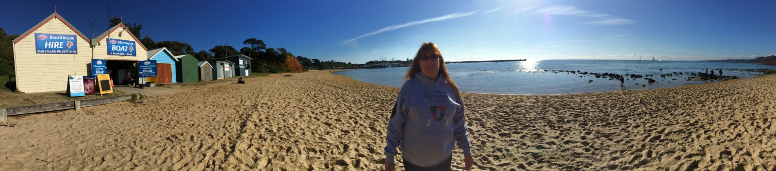

**PATRONS OF THE SOCIETY**

**His Grace The Duke of Hamilton ~ Lord Faulkner of Worcester ~ Lord Selkirk of Douglas**

**Sir Tam Dalyell Bt. ~ The Hon. Lady Rosalind Morrison ~ Mr. Henry Berkeley ~ Ms. Diane Rappaport**

**Professor Ron Hutton**

**Chairman:** Richard Shaw ~ **Vice-Chairman:** Vacant

**Executive Committee**

Kenneth Potts FBWS ~ Vaughan Wiltshire, Christine Shaw ~ Roger Fairman ~ Brian Bullock

**Black Pear Bulletin Editorial Team**

Richard Shaw, Christine Shaw

Registered Charity Number: 1160010

**© The Battle of Worcester Society 2016** [**www.thebattleofworcestersociety.org.uk**](http://www.thebattleofworcestersociety.org.uk)