The Black

Pear Bulletin

*The Newsletter of the Battle of Worcester Society*

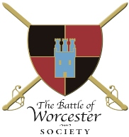Registered Charity Number: 1160010

**Issue No. 15 ~ Autumn Edition 2016**

**OUR CHAIRMAN WRITES**

Welcome to the Autumn edition of the *Black Pear Bulletin* for 2016. We have had an eventful and exciting Summer, reports of which are enclosed in this Bulletin. September is a particularly busy time for the Society as we commemorate the anniversary of the Battle on 3 September and this September we had something for everyone! This is also the time of year when we look back at our successes and plan to build on them in 2017. Our Annual General Meeting is to be held in The Studio at The Hive on Thursday 10th November at 7.15 p.m. This meeting is the perfect opportunity for members to let us know how we have done during the year and what you would like to see the Society undertake in the forthcoming year.

**CIVIL WAR NIGHTS**

**Thursday 1 September 2016**

Our first Civil War talk of this season was presented to us by one of our Trustees, Hannah (Worthen) Wilson and I am delighted to say that our season was closed by another female presenter, the Canadian Historical Novelist Cryssa Bazos. Cryssa kept the attention of the audience in The Commandery by telling us the tale of **The Royalist Highwayman** Captain James Hind who fought at the Battle of Worcester, escaped to London but was eventually arrested. He was hanged at Worcester and then quartered. His head was put on a spike on the river bridge and his body parts were then nailed to the city gates. Cryssa’s talk was attended by 45 people and we are thrilled that this season so many have come to support the Civil War Nights. In terms of attendance, this has been our most successful programme so far.

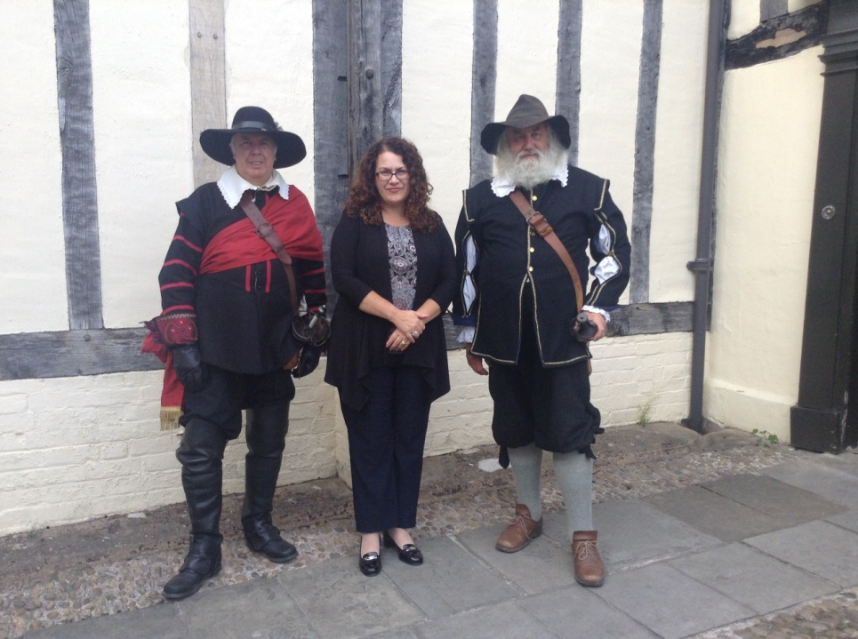

***Our guest speaker, Cryssa Bazos, with Worcester re-enactors Roger Fairman and Brian Bullock***

**EVE OF BATTLE DINNER**

**Friday 2 September 2016**

The Eve of Battle Dinner was held in the Royal Worcester Porcelain Museum and was organised by the Dinner Committee which was chaired by Vaughan Wiltshire, Executive Committee Member, who was more than ably assisted by David Hallmark, Tim Lawrence, David Nash, Kate Walton and me (just a little bit!). The beautiful menu card / memento was designed by Tim Lawrence and David Nash. This outstanding event was attended by 70 persons all of whom enjoyed a delicious meal with good conversation. We were additionally treated to an excellent after dinner address by Dr Stephen K Roberts entitled *“Consequences of the Battle of Worcester 1651”.*

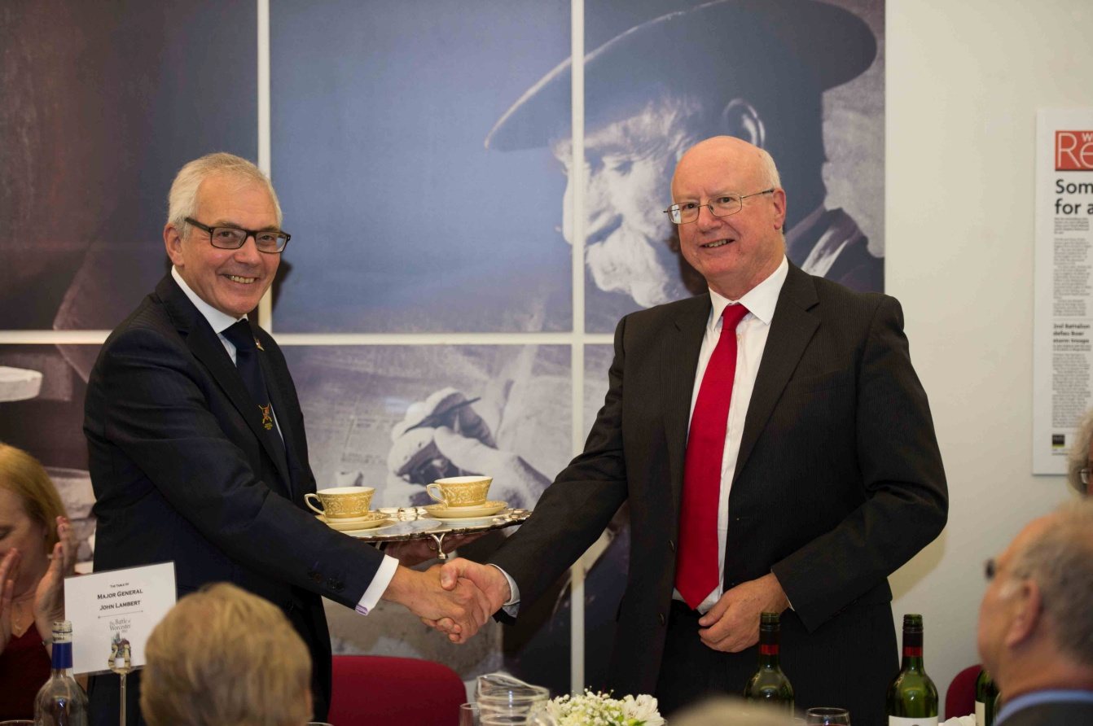

***Chairman of the Dinner Committe, Vaughan Wiltshire presenting Dr Stephen Roberts, our after dinner speaker***

***with a fitting thank you gift of Royal Worcester Porcelain***

Thank you to all who were involved in making this such an enjoyable and successful event.

**Battlefields Trust Walk**

**Saturday 3 September 2016**

Many brave people, including the Deputy Mayor and his wife, Steve and Alison Mackay, joined Tony Spicer, a Society and Trust member, in the pouring rain for a guided walk taking in the Ketch Viewpoint, Battenhall, Red Hill and Perry Wood.

**DRUMHEAD SERVICE – 365th ANNIVERSARY OF THE BATTLE**

**Saturday 3 September 2016**

The day was dark and wet and the weather did not improve greatly by the time we were due to assemble outside the Guildhall at 5.30 p.m. It did not rain, but it was wet underfoot and there were black clouds above so we did not have the crowds in the procession that we had anticipated. However, the Mayor and his ceremonial party did us proud. The procession, led by members of the newly formed Worcester Militia with flags and drums, were followed by the Mayor and Mayoress, the Swordbearer and Macebearers, who were followed by members of the Committee, the Society and public, wound its way from the High Street, into Pump Street, along Friar Street, College Street and Sidbury and into The Commandery Great Hall where we partook of liquid refreshment at a 17th century bar which had been set up by the Cardinal’s Hat.

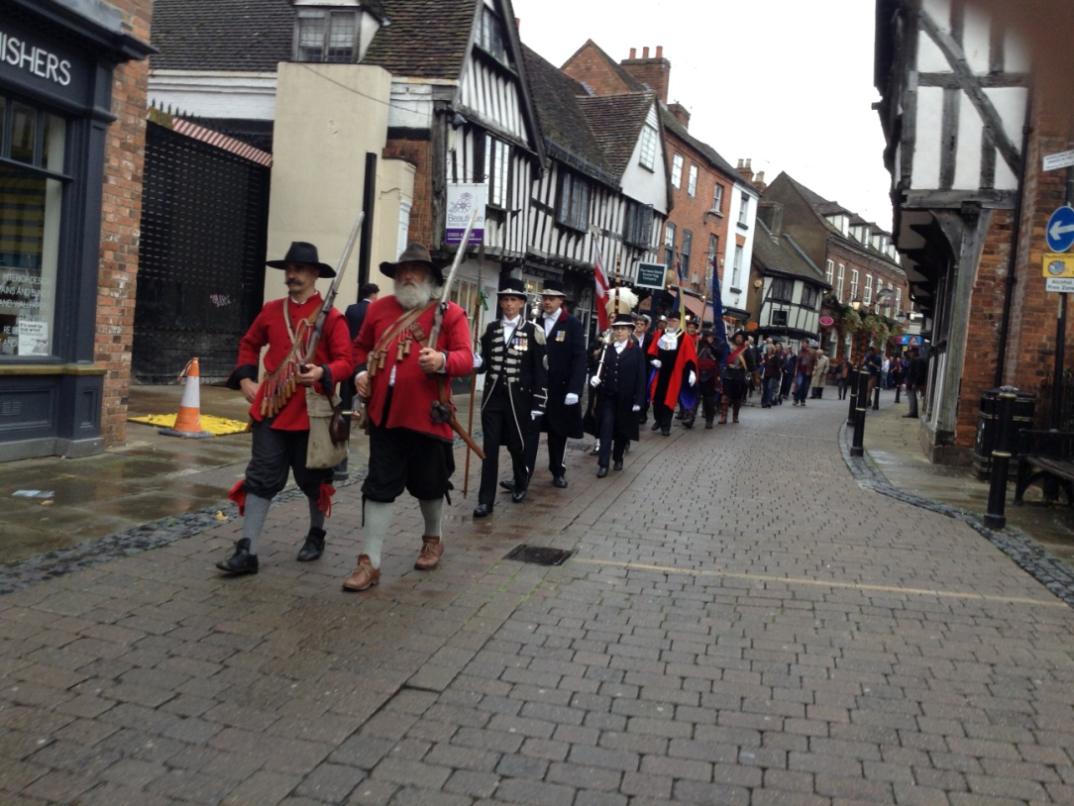

***The Procession led by members of the Worcester Militia in Friar Street***

At 6.45 p.m. we paraded to the top of Fort Royal Hill where we commemorated those who died in a service led by Canon Paul Tongue. The Militia fired off their traditional volleys and those assembled were addressed by the Chairman. Local poet, Bob Woodroofe also read his poem *Here* which documents the historical events which occurred on Fort Royal Hill. In addition to the Mayoral party one of our local patrons, Lord Faulkner, was in attendance. Approximately 75 people came to the Drumhead Service. Fort Royal Hill Park was looking particularly tidy after I arranged a litter pick and revarnished the information boards.

Afterwards the group returned to The Commandery where we were able to ‘Meet the Members of the newly formed Worcester Militia’.

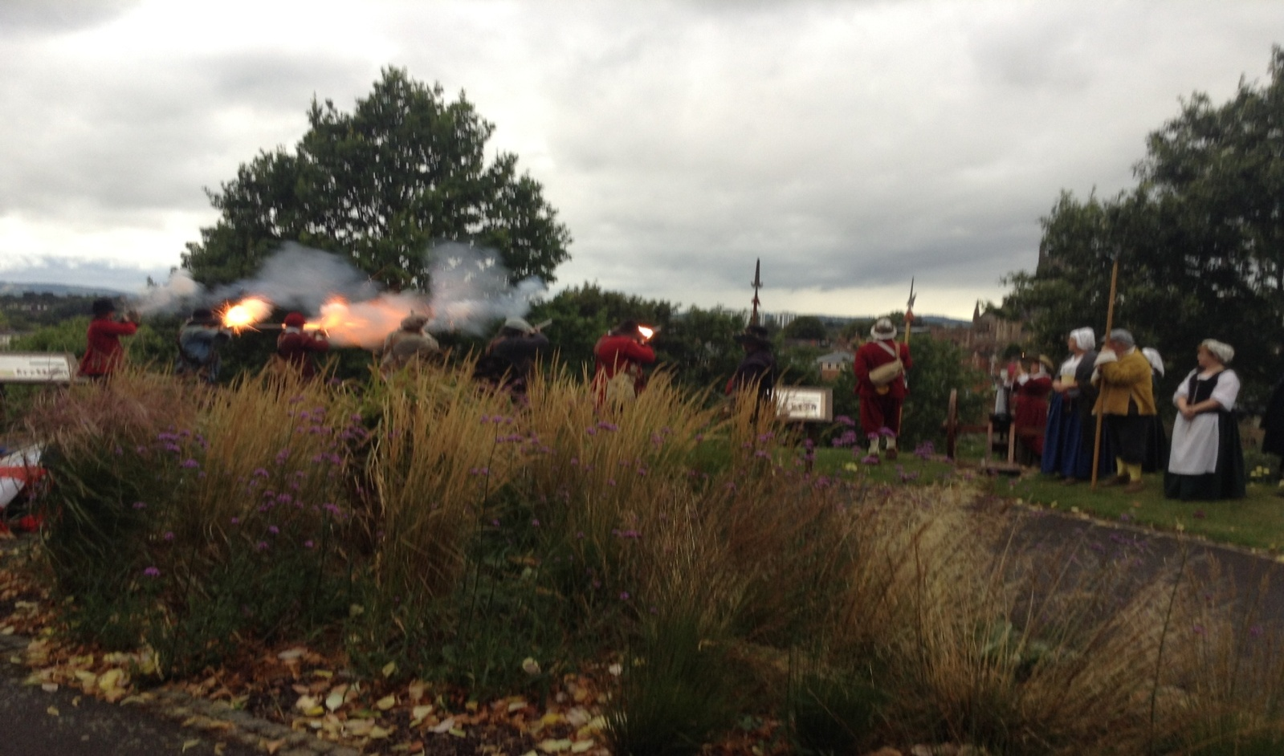

***Militia men firing a volley of muskets***

**OLIVER CROMWELL**

Society Member and retired Treasurer/Membership Secretary Howard Robinson played to a full Huntingdon Hall on the evening of 28th August 2016. Howard is a direct descendant of Oliver Cromwell and with finesse and aplomb he exploded many of the myths that surround the legend of the winner of the Battle of Worcester!

**BATTLE OF WORCESTER WEEKEND – A CIVILIAN’S STORY**

**Saturday 27/Sunday 28/Bank Holiday Monday 29 August 2016**

This event was attended by many and it is thanks to the Worcester Re-enactors who arranged for all the entertainment and Living History for people to take part in. Our Chairman even had a go at being a pikeman!

**BATTLE OF DUNBAR RE-ENACTMENT**

When we discovered that the Scottish Battlefields Trust, the East Lothian Council and the English Civil War Society had joined forces to put on a re-enactment of the Battle of Dunbar my wife and I became a little interested. When we heard that our Patron from the United States of American, Diane Rapaport, would be there to give a presentation on the Dunbar and Worcester Scottish Prisoners who were sent to the USA as indentured servants, we were even more interested. Diane became a Patron of the Society many years ago, long before I became involved in the Society, so it was an ideal opportunity to become acquainted with her. Diane is an historian, author, lawyer, and professional genealogist. Her presentation of “Scots for Sale” was very interesting and enlightening. She was accompanied by her partner, Dan Hamilton, and we have heard that since their return to Lexington, Dan suffered a heart attack. We do wish him a speedy recovery. <http://dianerapaport.com/>

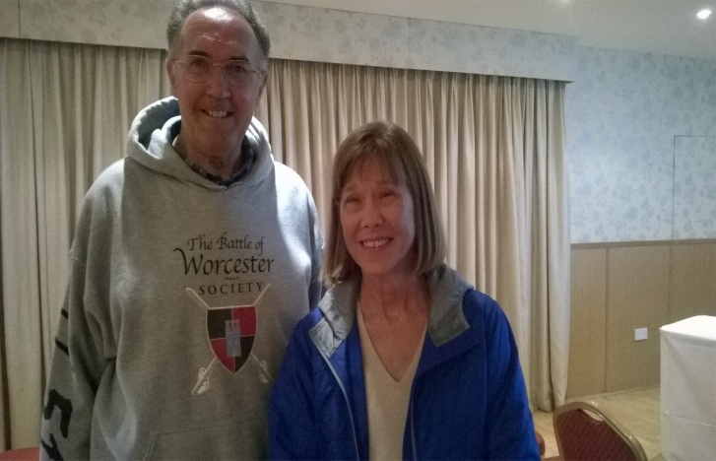

***BoWS Chairman Richard Shaw with USA Patron Diane Rapaport***

As you all know, the Battle of Dunbar took place on 3 September, 1650, exactly one year before the Battle of Worcester. Authorities in the East Lothian area have made a committment to supporting re-enactments of three particular battles, including Dunbar, and this year was the first of those commitments (the others being Prestonpans and Pinkie Heugh).

The re-enacment was held on the original battlefield by kind permission of the golf club which is immediately next to it. The weather was glorious for both days and we met many likeminded people. It also gave us a taste of what to expect should BOWS be successful in arranging its own re-enactment.

**WORCESTER 370 - 2021**

We are looking towards a full scale Sealed Knot re-enactment to mark the 370th anniversary of the battle. We have made a provisional booking with the Sealed Knot and are "opening a dialogue" with the City Council to see if this can be achieved. There is no additional news at the moment.

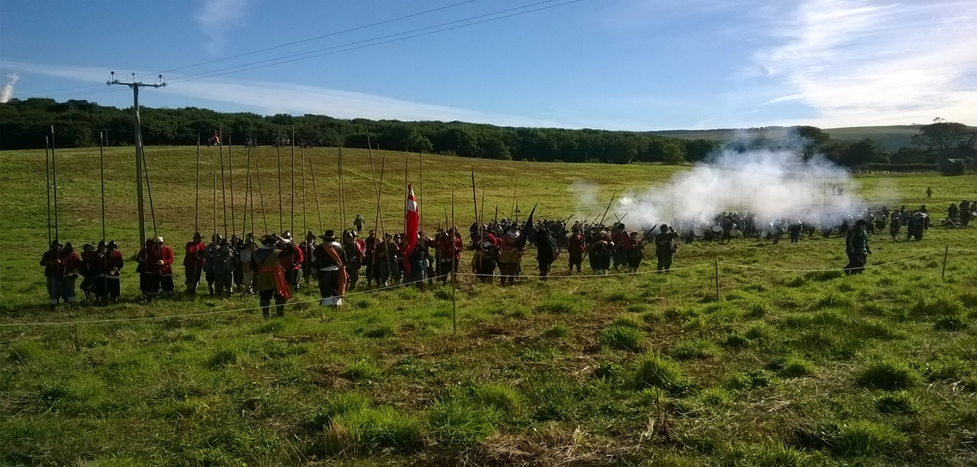

***A scene from the Battle of Dunbar re-enactment***

**SEALED KNOT FOUNDER’S DAY MEMORIAL SERVICE**

This service was held at Ripple Parish Church on Sunday 9 October. Brigadier Peter Young, the founder of the Sealed Knot retired to the area in the early 1970s and subsequently the SK Society adopted Ripple Church as its spiritual home. There was also a dedication of the newly installed plaque commemorating Brigadier Young. The church holds the Sealed Knot Grant of Arms, the Book of Remembrance and a stained glass window. It was a beautiful and colourful occasion. The Battle of Worcester Society was represented by Richard and Robina Rand, Christine Shaw and re-enactor Roger Fairman.

‘Brig’s’ ashes were distributed in the area and his wife is buried in the churchyard. A simple wreath laying ceremony was held after the memorial service.

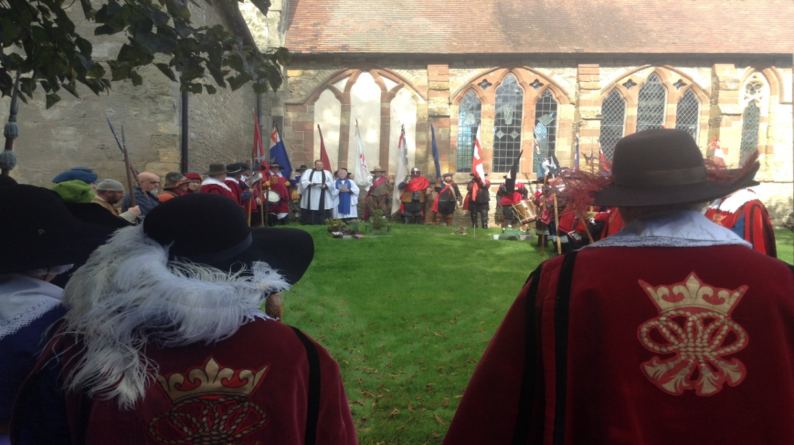

***Wreath laying ceremony***

**MONUMENT APPEAL**

Our work to progress the placing of the statue of John Adams and Thomas Jefferson in Fort Royal Hill Park continues, and further work has been added to the original Planning Application at the request of the Council.

**PIE AND A PINT**

**Thursday 6 October, 2016**

We are sorry to say that the pie and a pint evening at The King Charles House did not happen as the Chairman is/was recuperating from a major operation and is being looked after by the Events Secretary (his wife). We are looking to rearrange this evening for the early part of February. Details to be confirmed at a later date.

**MOSELEY OLD HALL**

**Spring, 2017**

We are still keen to arrange a coach trip to Moseley Old Hall, Staffordshire where you can find out about the dramatic story of Charles Stuart who hid from Cromwell’s troops at Moseley Old Hall after he fled the Battle of Worcester in 1651.

**ANNUAL GENERAL MEETING**

**Thursday 10 November, 2016 7.15 P.M.**

Our A.G.M. will start at 7.15 p.m. to allow members enough time to get to the Hive after work. The car parking fee is also down to a £1 for the evening after 7.00 p.m.

The meeting is being held in The Studio, The Hive, Sawmill Road, Worcester. Coffee, tea and biscuits on arrival. The AGM will be followed by drinks and canapés during which there will be the opportunity to meet the Committee and get to know fellow Society members. It is important that we achieve a quorum so please, all of you who can, come and support us. There will be important decisions to make regarding Trustees on this occasion. Documentation will be sent to you by email in the next few days.

**SITUATIONS VACANT**

We would still like to hear from Members who feel that they may be able to help the Society in any way, either officially or unofficially and/ or just as a one-off at events etc.

**CHRISTMAS TREE FESTIVAL**

**2 December 2016 until 6 January 2017**

In the Cloister of Worcester Cathedral. All proceedings go the charity, the Daisy Chain Benevolent Fund, but it is also the ideal opportunity to advertise the Society, its Aims and Objectives.

**CHRISTMAS LUNCH**

**Sunday 11 December, 2016**

Our next Christmas lunch will be held at The Whitehouse Hotel, Foregate Street, Worcester. The hotel has historical connections when it was known as The Star Hotel. The dining room is on the ground floor and there is parking at the back of the hotel accessed from Foregate Street. The Adams and Jefferson plaque is on the wall outside as they had breakfast next door in April 1786. Menu details will be sent to you very shortly.

**R.I.P**

Society Member Dr Anna Valerie Adcock passed away peacefully in Rushwick on 28 September 2016 aged 73 years. A funeral service is to take place at Worcester Crematorium on Thursday 20 October at 1.00 p.m. to which friends are respectfully invited. (Details taken from *Worcester News*)

Anna was a great supporter of BOWS and particularly the Civil War Night talks and the Scottish cause!

**PATRONS OF THE SOCIETY**

**His Grace The Duke of Hamilton ~ Lord Faulkner of Worcester ~ Lord Selkirk of Douglas**

**Sir Tam Dalyell Bt. ~ The Hon. Lady Rosalind Morrison ~ Mr. Henry Berkeley ~ Ms. Diane Rapaport**

**Professor Ron Hutton**

**Executive Committee**

Richard Shaw (Chairman) - Kenneth Potts ~ Vaughan Wiltshire, Christine Shaw ~ Roger Fairman ~ Brian Bullock

**Black Pear Bulletin Editorial Team**

Richard Shaw, Christine Shaw

**© The Battle of Worcester Society 2016** [**www.thebattleofworcestersociety.org.uk**](http://www.thebattleofworcestersociety.org.uk)