The Black

Pear Bulletin

*The Newsletter of the Battle of Worcester Society*

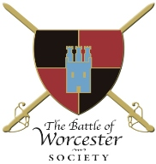Registered Charity Number: 1160010

**Issue No. 16 ~ Spring Edition 2017**

**OUR CHAIRMAN WRITES**

Welcome to the first edition of the *Black Pear Bulletin* for this year. May I start by wishing you all a happy and healthy new year. It looks like being a busy and interesting 2017. January can be a time for reflection and when I look back at 2016 I am pleased at what the Society has achieved. The Society has reached more people than ever before with the Civil War Night Season of talks and the events surrounding the 365th commemoration of the Battle of Worcester which we held on 1st, 2nd and 3rd September. Our audiences for the Civil War talks were larger than they ever have been, due we think, to the fact that the people of Worcester now know what to expect from our gatherings. The Eve of Battle Dinner was supported by many who were not members of the Society and the Drumhead Parade and Service brought living history to many people on the streets of Worcester and on Fort Royal Hill. We aim to build on this success throughout the coming year.

**CHRISTMAS LUNCH**

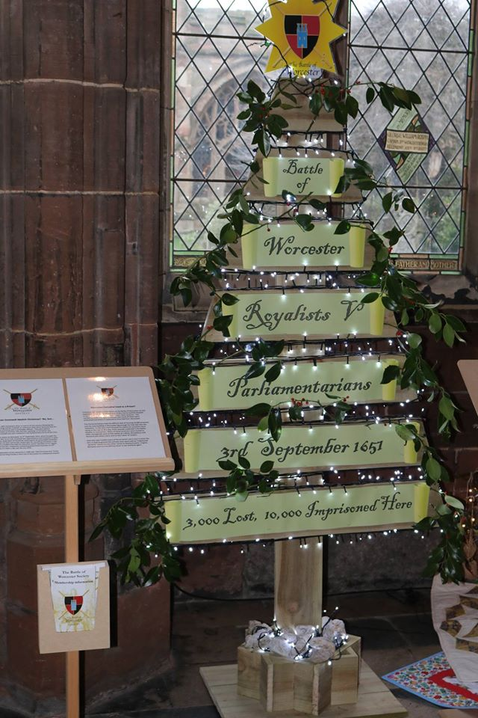Thirty members of the Society met for lunch in the County Suite at The Whitehouse Hotel on Sunday 11 December, 2016 and was an extremely enjoyable event. Thanks to Christine Shaw for organising the lunch.

**CHRISTMAS TREE FESTIVAL**

Our entry in the Christmas Tree Festival in the Cloister of Worcester Cathedral was also very successful. Designed by Christine Shaw, made by her brother John Hodges with artistic design and development by Brian Bullock and Kenneth Potts, the tree carried the information that highlighted the huge role the Cathedral played during the aftermath of the Battle of Worcester.

All of the membership leaflets we put out (at least 50) were taken as were the flyers promoting the Monument Appeal, so a lot of people have now heard of us!

*(Photograph by David Butler – BOWS Facebook page)*

**EXCITING CHANGES AT THE COMMANDERY**

There are some exciting changes afoot at The Commandery this year. In summer 2017, Worcester's Civil War Story – an interactive new experience – will be installed throughout an entire wing of the building, dedicated to bringing The Commandery's civil war past to life.

Visitors will be immersed in the smells and sounds of battle, discover 17th century characters, see the death mask of Oliver Cromwell and witness the bloody effects of the Battle of Worcester on the city.

Worcester-based **modus Creative** have created a new visual identity and proposition for The Commandery:

Bringing to life tales of treason, treachery and tragedy

in this beautiful building with a bloody past,

in the heart of historic Worcester

where the English Civil War began and ended.

Improvements are made possible by a cash injection of £260,000 from Worcester City Council, £96,000 from the Heritage Lottery Fund (HLF) and further funding from Worcestershire County Council, Arts Council England, the Sealed Knot and The Friends of Worcester Museums and Art Gallery who have donated £5,400.

This article has been written for us by:

Charlie Fothergill, *Marketing Officer*, The Commandery, *Digital Marketing Assistant,* Museums Worcestershire

Together with other Partners of The Commandery I have seen several presentations by the Commandery Manager, David Nash and it is a very exciting project. (RJS)

**MONUMENT APPEAL**

Our work to progress the placing of the statue of John Adams and Thomas Jefferson in Fort Royal Hill Park continues, and further work has been added to the original Planning Application at the request of the Council. The project has received favourable comments . Fort Royal Park is a Scheduled Monument and as such we also need to obtain consent from Historic England. This aspect is being dealt with by the Council’s Parks Department. We are sure that this monument will be a major tourist attraction particularly for the Americans. The Commandery proposes to have an Adams and Jefferson room explaining the importance of their visit to Worcester in 1786 which will complement our plans for the statue magnificently.

I recently read David McCullough’s 650 page biography of John Adams. In the epilogue, he says that while there was no doubting the historic importance of John Adams, there was no statue of him anywhere in the world. With this in mind I wrote to him in Massachusetts telling him of our project here in Worcester. He replied a few weeks later to say that he was very interested in the Monument project and asked to be kept up to date with its development.

T o continue the Presidential theme:

**OH NO, NOT HIM AS PRESIDENT!**

"Murder, robbery, rape, adultery and incest will all be openly taught and practised." This was the prediction made when the new President of the USA was sworn in. No, not Donald Trump in 2017 but the famous Worcester visitor of 1786, Thomas Jefferson in 1800. With roughly half of America and much of the rest of the world forecasting that a Trump Presidency would be a global catastrophe, it is worth recording one of the older aspects of American elections, the doomsayers are frequently wrong and sometimes spectacularly so. Jefferson took office amid predictions that he would plunge America into disaster but he turned out to be one of the country's greatest presidents. He served for two offices until 1809, purchased Louisiana Territory for the USA from Napoleon Bonaparte in 1803 and founded the University of Virginia. He has a huge memorial in Washington and his face is carved into Mount Rushmore, but somehow I don't see any of that happening for Donald Trump?

Richard Shaw (*with thanks to Ben MacIntyre@TheTimes)*

**CORPORATE SPONSOR**

Mr Nigel Smith of The Cardinal’s Hat in Worcester and The Fleece at Bretforton (a National Trust property) has agreed to be a Corporate Sponsor of the Battle of Worcester Society and as such will be donating £100 per year for the next three years. As a token of our appreciation we have organised a Sunday lunch at The Fleece for BOWS on Sunday 21st May. The meal will be followed by some entertainment. More details to follow so please save the date.

**NEW TRUSTEES**

At our Annual General Meeting on 10 November 2016 we welcomed former Chairman Grant Simmonds as one of our Trustees. Grant is now the Chairman of the Battle of Worcester Heritage Partnership which is a group consisting of all organisations with an interest in the battle.

Since the AGM Steve Hunt of the Worcestershire Ambassadors and a keen supporter of the Society has also agreed to be a Trustee.

We welcome them both wholeheartedly to the Board of Trustees and look forward to working with them for the benefit of Worcester and BOWS.

**CIVIL WAR NIGHTS**

The process for organising another season of talks is ongoing and some dates have yet to be set. We have a good mix of speakers already booked including:

**Dr David Appleby**, Lecturer in Early Modern British History, University of Nottingham. His subject will be *Runaways, Deserters and the Negotiation of Parliamentary Authority in Civil War England 1642-1651.*

**Howard Robinson** direct descendant of the great General himself, Oliver Cromwell – whose presentation is entitled *Worcester, Where England's Sorrows Began and Where They are Happily Ended.* (23 September is the 375th anniversary of the skirmish at Powick)

**Dr Stephen Roberts**, of the Worcestershire Historical Society, who spoke at our Eve of Battle dinner. He will be speaking on *Oliver Cromwell and Parliament*

**Stuart Peachey**, Historian and Author, who will be speaking on a *A Soldier’s Life*

**Keith Dowen** from Leeds Armouries. His subject is *Arms and Armour of the Civil War.*

**MAYOR’S PARLOUR VISIT FOLLOWED BY A PIE AND A PINT**

We are sorry that the pie and a pint evening at The King Charles House did not happen on the 6th October, **but** re-arrangements for this event are now in full flow. On **Monday 6th February 2017**, we will be visiting the Mayor’s Parlour as the result of a kind invitation by the Deputy Mayor, Mr Steve Mackay. Steve has arranged for Mr Steve Baker who has a full historical knowledge of the Treasures of the Mayor’s Parlour to look after us. We will then stroll down to King Charles’ House for a social evening. Please get in touch if you would like to come - either to the Mayor’s Parlour or to the Pie and Pint event or both. At present we have 25 people coming along to the whole evening’s proceedings. The cut off date for menu choices is Wednesday 1st February, 2017. Please email Christine at [seashells84@sky.com](mailto:seashells84@sky.com) if you are interested.

**DATES FOR YOUR DIARY**

**Saturday 18th February and Sunday 19th February (10am - 5pm)**

*2,000 years of history are brought to life* with a weekend full of ancient Greeks, Viking warriors, the two World Wars and much more at The Commandery, Sidbury, Worcester. Organised by Worcester Re-enactors in partnership with The Commandery, Living History in Worcester is part of Love Worcester Heritage Festival, a week of events in heritage venues across the City from 18th - 26th February 2017.

**21st May, 2017**

*Lunch at The Fleece, Bretforton*

A mini bus will be made available, should we have sufficient interest.

**MOSELEY OLD HALL**

**Spring, 2017**

We are still keen to arrange a coach trip to Moseley Old Hall, Staffordshire where you can find out about the dramatic story of Charles Stuart who hid from Cromwell’s troops at Moseley Old Hall after he fled the Battle of Worcester in 1651. An indication of interest from members would be much welcomed.

**CIVIL WAR NIGHTS 2017**

**May** (specific date to be confirmed) – Stuart Peachey

**Thursday 8 June** – Stephen Roberts

**July** (specific date to be confirmed) Keith Dowen

**Thursday 3rd August** – David Appleby

**Thursday 21st September** – Howard Robinson

**BBC HISTORY MAGAZINE - FEBRUARY ISSUE - JUST RELEASED**You may be interested to know that the cover story of this issue is entitled "Cromwell - The Secret of his Military Genius" which is written by Professor Martyn Bennett, a well known and respected author of the Civil War period. (His next book, "Cromwell at War: The Lord General and His Military Revolution" will be published later in the year).

**R.I.P.**

We are sad to report that one of our patrons, Tam Dalyell (Sir Tam Dalyell Bt**.)** died on 26th January 2017 aged 84 years.  He had been the Labour MP for West Lothian for 43 years until he retired in 2005.  His ancestor also known as Tam Dalyell (or Dalzeil in some accounts) was a Royalist General at the Battle of Worcester, and because of this connection, the 21st century Tam was invited to Worcester in 2001 to unveil the Battle of Worcester commem -orative stone at Powick Bridge.  He then agreed to be a patron of the society.

His ancestor General Tam Dalyell (1615-1685), 1st Baronet of the Binns (an estate near Edinburgh) commanded a Scottish regiment at the Battle of Worcester but was captured and imprisoned in the Tower of London, from where he escaped in 1652.  A reward of 200 guineas was offered for his recapture, but he made it to the continent and became a Lieutenant General in the Russian Army.  With the restoration of King Charles II he returned to Scotland in 1666.  He is credited with raising the Scots Greys regiment in 1681.

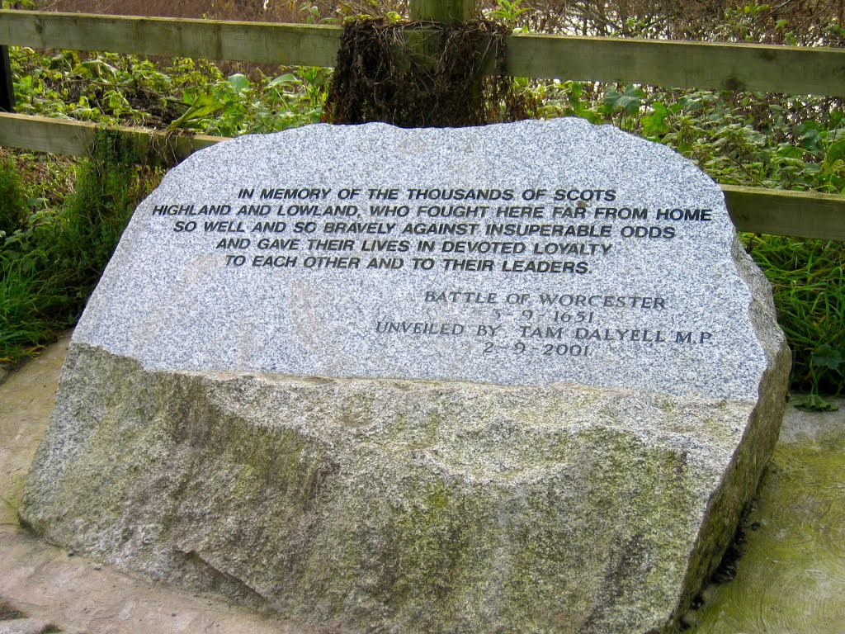

**SITUATIONS VACANT**

We would still like to hear from Members who feel that they may be able to help the Society in any way, either officially or unofficially and/ or just as a one-off at events etc.

**- o0o -**

**PATRONS OF THE SOCIETY**

**His Grace The Duke of Hamilton ▪ Lord Faulkner of Worcester ▪**

**Lord Selkirk of Douglas ▪ The Hon. Lady Rosalind Morrison ▪**

**Mr. Henry Berkeley ▪ Ms. Diane Rapaport ▪**

**Professor Ron Hutton**

**Executive Committee**

**Richard Shaw (Chairman) ▪ Kenneth Potts ▪ Vaughan Wiltshire,**

**Christine Shaw ▪ Roger Fairman ▪ Brian Bullock**

**Trustees**

**Richard Shaw ▪ Vaughan Wiltshire ▪ Jack Randall ▪ Peter Brookes ▪**

**Hannah Worthen ▪ Derek Law ▪ Tim Lawrence ▪ Christine Shaw ▪**

**Roger Fairman ▪ Grant Simmonds ▪ Steve Hunt**

**Black Pear Bulletin Editorial Team**

Christine Shaw, Richard Shaw

**© The Battle of Worcester Society 2017** [**www.thebattleofworcestersociety.org.uk**](http://www.thebattleofworcestersociety.org.uk)