The Black

Pear Bulletin

*The Newsletter of the Battle of Worcester Society*

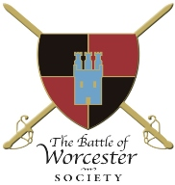Registered Charity Number: 1160010

**Issue No. 17 ~ Summer Edition 2017**

**OUR CHAIRMAN WRITES**

Dear Members,

It has been a very busy few months for both the Society and me since the last edition of the Bulletin with social events and progress being made with the Monument Appeal and meetings regarding every aspect of the Society, The Commandery and Fort Royal Park. I hope you enjoy reading about them. Enjoy the summer!

**TREASURES OF THE MAYOR'S PARLOUR + PIE AND A PINT**

At the invitation of the then Deputy Mayor( now Mayor) Steve Mackay, who also happens to be a Battle of Worcester Society member, 25 members visited the Mayor's Parlour during the evening of Monday 6th February 2017. Steve had arranged for Steve Baker, a former Mayor's Officer, to give us a presentation on the historical treasures held by the office of the Mayor of Worcester. Steve Baker had a fascinating knowledge of all of the artefacts which were passed around the group. We then visited The King Charles House in New Street where we indulged in their excellent variety of pies together with a pint (or two) of their excellent variety of brews. Many thanks to the two Steves for their invitation and a big thank you to Christine Shaw for organising an interesting and convivial evening.

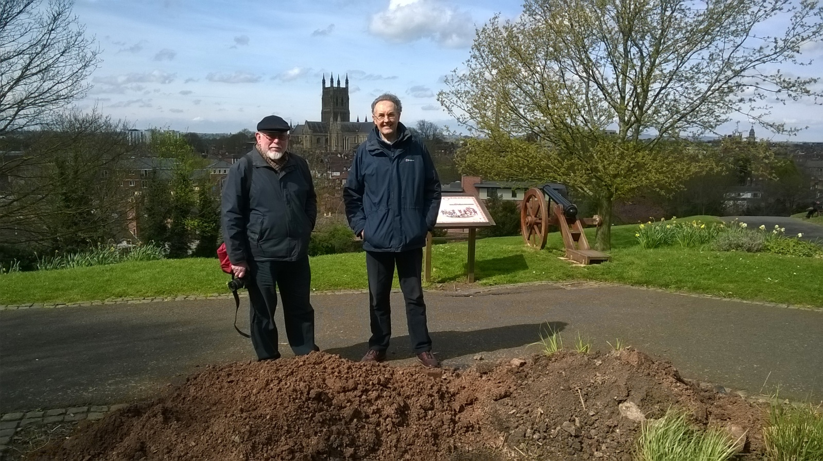

**JOHN ADAMS AND THOMAS JEFFERSON MONUMENT UPDATE**

Formal Planning Permission was granted by Worcester City Council on 1st February 2017. We still await Scheduled Monument Consent from Historical England and this is being dealt with by James Dinn, Worcester City Archaeologist. This is progressing well and Historic England requested that a test pit be dug on the proposed site to ensure we are not building on any archaeology. This was done on 3rd April 2017 and James Dinn reported that there were no problems and he would submit a report to Historic England to this effect. The picture above of the Sculptor and Battle of Worcester Society member, Ken Potts and our Chairman Richard Shaw standing by the test pit, appeared in the Worcester News on Saturday 8th April, which was the anniversary of Adams' and Jefferson's visit to Worcester in 1786.

Our MP and Battle of Worcester Society member Robin Walker informed us that he had been recently speaking to Nigel Adams, MP for Selby and Ainsty in North Yorkshire. Nigel mentioned that he was a direct descendant of John Adams. We wrote to Nigel asking if he would lend his support to the Monument Appeal and he has agreed to do so. If he gets back in on 8th June we will follow that up further.

We are also looking towards a formal launch date of the appeal which could well be 3rd September2017. However, it may prove difficult to get media coverage on the 3rd as it is a Sunday.

Incidentally, I wrote to President Trump on 31st Match 2017 telling him about our project and asking him if he would like to donate...he hasn't replied as yet!

**GREEN FLAG AWARD FOR FORT ROYAL PARK**

Worcester City Council has applied for Green Flag status for Fort Royal Park. Judging is to take place on Monday 5th June 2017 when I have been requested to make a presentation to the judges on the Battle of Worcester and the Adams and Jefferson project. Wish me luck!

**THE COMMANDERY'S CIVIL WAR REFURBISHMENT**

The Battle of Worcester Society has agreed to donate £1,000 to the refurbishment of the Commandery, and I have been invited to the opening ceremony on Saturday 29th July. The Commandery has also commissioned an eleven minute film to be shown to visitors to the Commandery. They are looking at the 'World Premier' of this film being shown on Sunday 3rd Septembers 2017, after our Drumhead Service.

**THE KING'S SHILLING**

I recently gave a talk to a Worcester U3A group on 15th March 2017 and after several standing ovations (!) I was approached by Mrs Yvonne Hanns who informed me that in 2001 her husband, now deceased, was digging his garden at Fort Royal Hill when he found a coin which Yvonne believed could be from the Battle of Worcester. It had been in a jar at her home ever since and she wondered if the Battle of Worcester Society would like to have it. We met a few days later and Yvonne handed the coin to me and I took it to the Museum and Art Gallery for examination by their resident expert Mr Garston Phillips. He showed it to a numismatist who concluded that it was a King Charles I silver shilling from the Tower Mint dated 1643. Strangely its value was only put at £100, but the fact that it was found in a garden that backs on to Fort Royal Park on ground that was part of the Royal Fort in 1651 increases its historic value to Worcester and it is very likely that it was dropped during the fierce fighting in Fort Royal on 3rd September 1651. It is to go on display as part of the Commandery refurbishment.

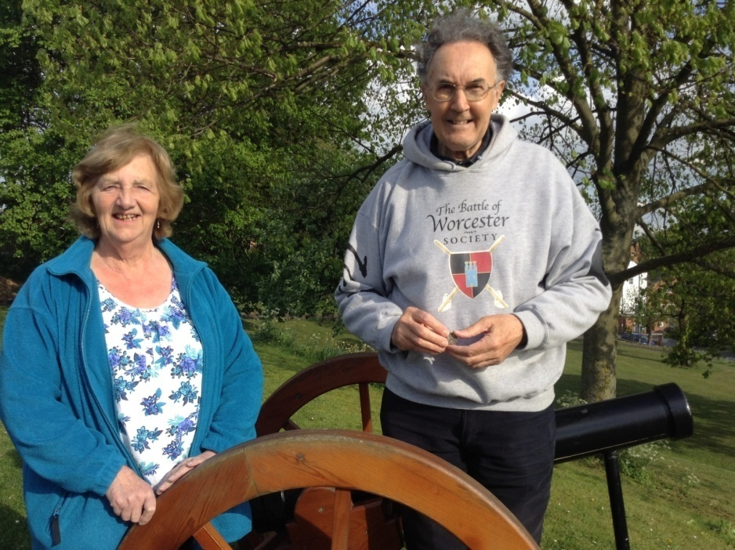

**BLACK PEAR TREE PLANTING**

On 15th May I was invited to plant a Black Pear tree in the Commandery Gardens. Apart from the tree being named after our Bulletin there is no connection with the Battle of Worcester but it is an interesting story. The Black Pear Tree has a 500 year association with Worcester and was popular due to its quality of producing a very abundant, long lasting crop which would last all through the winter months. It was not a good eater, but made a very good stew. It was part of the provisions for King Henry V's troops at Agincourt (25th October 1415) where the Worcestershire Bowmen carried banners depicting a Black Pear tree laden with fruit. When Queen Elizabeth I visited Worcester in August 1575 the city authorities had a Black Pear fruit laden tree transplanted at The Foregate in her honour. So admiring was she of the good management that had allowed the fruit to remain unpicked that she ordered "Three Pears Sable" to be added to the city's coat of arms. Worcester has obeyed that order ever since.

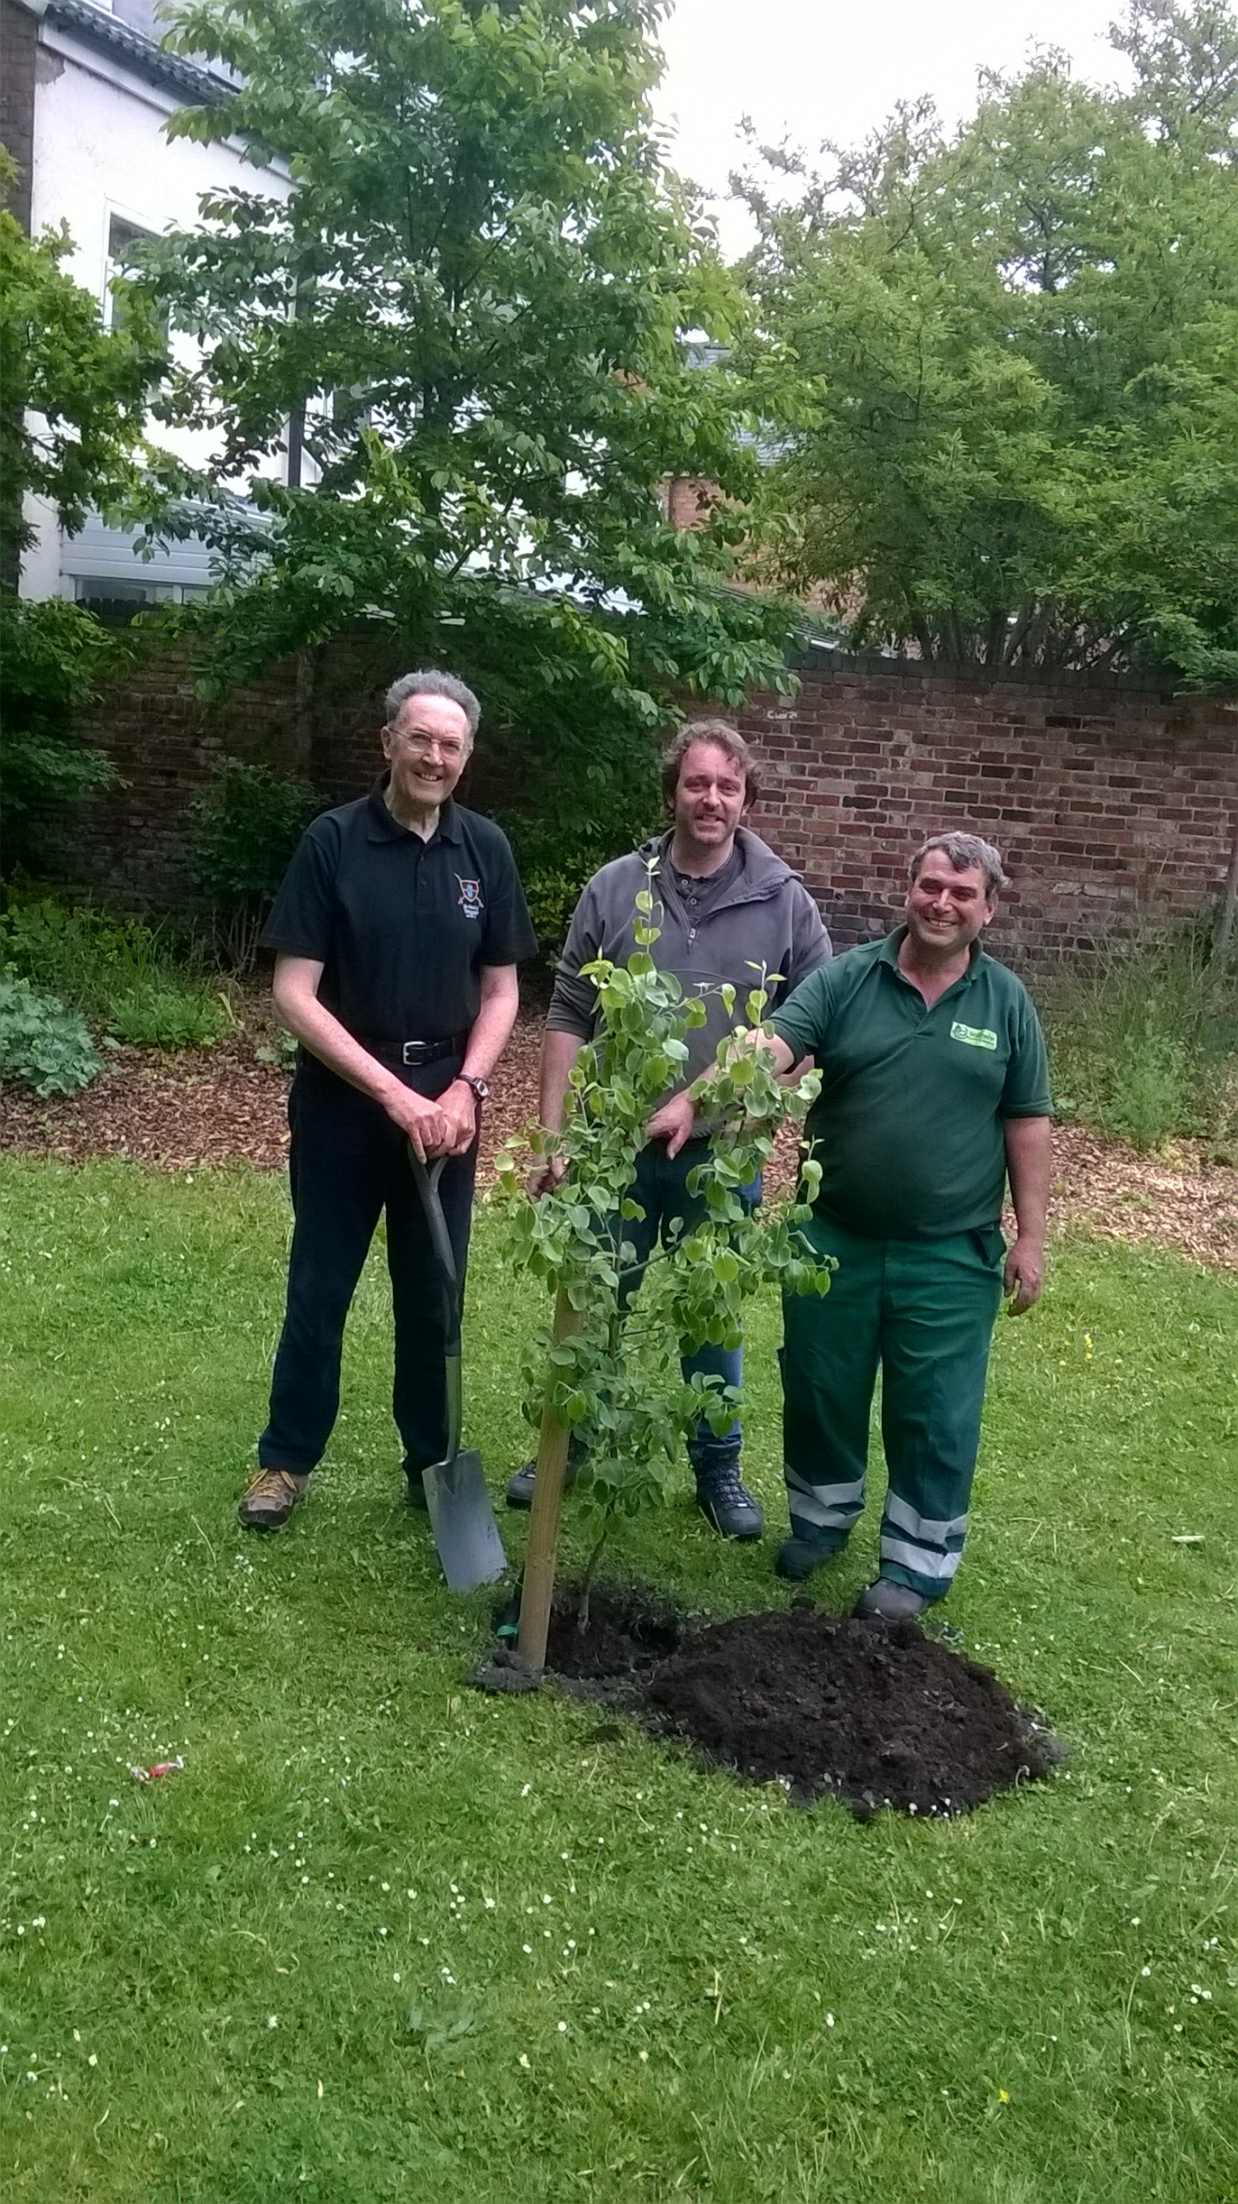

**FIRST CIVIL WAR NIGHT EVENT - THURSDAY 18TH MAY 2017**

Our first speaker of the season was **Stuart Peachey** who gave a very detailed presentation on *'A Soldier's Life'.* Thirty three people were present and Mr Peachy showed them replica clothing that soldiers would have worn. He also had a detailed knowledge of their diet and weaponry. Many of his books were on sale which Stuart signed and the new Commandery Cafe did a good trade.

Our next talk is on **Thursday 8th June 2017** by **Dr Stephen Roberts**, who spoke at our Eve of Battle dinner in September last year. He will be speaking on '*Oliver Cromwell and Parliament'*. You may have noticed that this is on General Election day, but Stephen was booked well before the election date was selected! Stephen is the editor of the History of Parliament's forthcoming volumes on the House of Commons, 1640-1660, so, unlike many of our MPs (Mr Robin Walker NOT included) he knows what he is talking about.

After that on **Thursday 6th July** we have **Keith Dowen**, the Assistant Curator of European Armour at The Royal Armouries, Leeds talking about '*Arms and Armour of the Civil War'* so he will be someone else who knows his stuff.

On **Thursday 3rd August Dr David Appleby** a Lecturer in Early English Modern History at the University of Nottingham has chosen the lengthy title of '*Runaways, Deserters and the Negotiation of Parliamentary Authority in Civil War England 1642-1651'*  for his talk.

Our last talk of the season will be on **Thursday 21st September** when our very own **Howard Robinson,** direct descendant of Oliver Cromwell, will be covering the Battle of Powick Bridge the first major engagement of the Civil War on 23rd September 1642, which has its 375th anniversary this year. Howard's talk is entitled '*Worcester, where England's Sorrows Began and Where they are Happily Ended.'*

**SUNDAY LUNCH AT THE FLEECE INN, BRETFORTON SUNDAY 21st MAY 2017**

This was a really lovely event in a beautiful location with wonderful weather. Twenty one members attended. Our host and Corporate Sponsor Nigel Smith laid on an excellent musical duo who serenaded us through our meal on a sunny spring day.

**BATTLE OF WORCESTER HERITAGE PARTNERSHIP PROJECTS**

This group is made up of other organisations, in addition to the BoWS that have an interest in the Battle of Worcester, such as the Commandery, the Cathedral, the City Council, the Battlefield Trust, the Cromwell Association, the Worcestershire Historical Society and the Sealed Knot. It is chaired by the BoWS' former chairman Grant Simmonds who supports the BoWS with their projects. Grant is keen that the BoWHP makes a contribution to the Civil War importance of Worcester and has instigated two projects for the group to progress.

Firstly, it is hoped that an Information Broad can be placed at the confluence of the rivers Teme and Severn showing the Parliamentary bridges of boats across these two rivers.

Secondly, you may recall that there was a huge mural of the Battle of Worcester on the wall of the shoe store at Barbourne. This was destroyed when the shop changed hands and the building front redesigned. The BoWHP have been looking at other possible sites for a mural and Skellern's motor cycle shop in Sidbury, the site of the Sidbury Gate, has been suggested. The proprietor is in favour and our BoWS member Ken Potts has been considering a number of options to be placed on the wall. Both projects are at an early stage of development.

**WHERE'S CHRISTINE?**

Our Secretary/Treasurer/Membership Secretary/Events Organiser/Merchandise Stockist/Black Pear Bulletin Editor/Trustee and Monument Committee member Christine Shaw was admitted to the Alexandra Hospital, Redditch on 3rd May with severe abdominal pain. After two weeks in hospital she was diagnosed with having abscesses on her liver. She was released on 16th May and attended the Fleece Inn function but was back in hospital on 22nd May following an allergic reaction to the antibiotics. After a further three days in hospital she was allowed home to have the antibiotics administered by intravenous drip by a District Nurse. Suffice to say she was hugely missed and we look forward to seeing her back in action before too long.

**POWICK FETE SATURDAY 1st JULY 2017**

BoWS has accepted an invitation made by the Powick Fete Committee to attend their Annual Fete on 1st July 2017. It is appropriate we have a presence there as Powick saw some Civil War Action. We will be selling our merchandise with the hope of raising money for the Society’s funds. If anyone would like to offer some assistance it would be greatly appreciated.

**SITUATIONS VACANT**

We would still like to hear from Members who feel that they may be able to help the Society in any way, either officially or unofficially and/ or just as a one-off at events etc.

**- o0o -**

**PATRONS OF THE SOCIETY**

**His Grace The Duke of Hamilton ▪ Lord Faulkner of Worcester ▪**

**Lord Selkirk of Douglas ▪ The Hon. Lady Rosalind Morrison ▪**

**Mr. Henry Berkeley ▪ Ms. Diane Rapaport ▪**

**Professor Ron Hutton**

**Executive Committee**

**Richard Shaw (Chairman) ▪ Kenneth Potts ▪ Vaughan Wiltshire,**

**Christine Shaw ▪ Roger Fairman ▪ Brian Bullock**

**Trustees**

**Richard Shaw ▪ Vaughan Wiltshire ▪ Jack Randall ▪ Peter Brookes ▪**

**Hannah Worthen ▪ Derek Law ▪ Tim Lawrence ▪ Christine Shaw ▪**

**Roger Fairman ▪ Grant Simmonds ▪ Steve Hunt**

**Monument Committee**

**Lord Richard Faulkner (Chairman) - Richard Shaw - Christine Shaw - Jack Randall - Ken Potts**

**Vaughan Wiltshire - Peter Brookes - Steve Hunt - Ben Humphries - Grant Simmonds**

**Black Pear Bulletin Editorial Team**

Christine Shaw, Richard Shaw

Tel. 01905 358640

**© The Battle of Worcester Society 2017** [**www.thebattleofworcestersociety.org.uk**](http://www.thebattleofworcestersociety.org.uk)