The Black

Pear Bulletin

*The Newsletter of the Battle of Worcester Society*

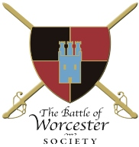Registered Charity Number: 1160010

**Issue No. 19 ~ Winter Edition 2017/18**

**OUR CHAIRMAN WRITES**

A happy, healthy and prosperous New Year to all our members and friends of the Society. 2017 was a full and exciting year for BOWS with events ranging from Civil War talks, the commemoration of the skirmish at Powick Bridge to Earl Spencer giving an illustrated talk in the Guildhall and finally to the Christmas Lunch at The Whitehouse Hotel in Worcester. A round up of these events follows in this newsletter.

**GREAT NEWS!**

Charles, Earl Spencer has agreed to be a Patron of the Society. He is renowned for his interest in history and we are delighted to welcome him to our already illustrious group of Patrons.

I have also been in touch with Sir Robert Worcester of MORI Poll fame regarding the Adams and Jefferson Monument Appeal (more of which below) and he too has agreed to become a Patron of the Society.

**ADAMS AND JEFFERSON MONUMENT APPEAL**

Following £1,000 donations from both Sir Robert Worcester and Nigel Adams MP the fund has reached £8,750.  After a very successful talk by Earl Charles Spencer on 4th December and our Christmas Draw on 10th December the Society is able to top this up to £10,000.  I have sent brochures to:-The Worcester Telegraph & Gazette(USA); the Governor of Massachusetts; Harvard University (where Adams was a student); The Adams National Historical Park in Quincy, Massachusetts and The Thomas Jefferson Heritage Society,  Charlottesville, Virginia seeking donations.    Scheduled Monument Consent is still awaited but no problem with this is anticipated.

**BATTLE OF WORCESTER HERITAGE PARTNERSHIP PROJECT**

Is, as you know, an amalgamation of all parties who have an interest in the battle such as: The Battlefield Trust, The Cromwell Association, The Sealed Knot, The Commandery, The Cathedral, Worcester City Council and of course BoWS.  They meet quarterly in the Guildhall and former BoWS Chairman, Grant Simmonds is the Chairman.

They have commenced a project to place an information board at the confluence of the rivers Teme and Severn, showing the Parliamentarian Bridges of Boats to cross these two rivers during the battle of Worcester.  After generous donations, including £100 from BoWS the target has been reached and it is hoped that the information board will be in place this summer.

**ROUND UP OF EVENTS in 2017**

**Tour of the Battle of Worcester Exhibition at The Commandery**

**Tuesday 24th October**

A free tour of the new Battle of Worcester Exhibition was offered by David Nash who is the Manager and Curator of The Commandery. 30+ members, partners and friends enjoyed the tour immensely and equally enjoyed their fish and chip supper. It was a great opportunity to see all the hard work that had gone into the exhibition and it was a chance to get together and socialise. Thank you to David for guiding us, Gemma in the Commandery cafe for staying open late and to Seacrest Fish and Chip Shop for organising our supper so well.

**BOWS AGM in The Studio at The Hive**

**Thursday 23rd November**

The AGM was attended by 28 members in The Studio at The Hive, Worcester. Coffee, tea and biscuits were available on arrival. I hope that all members have received a copy of the minutes and supporting papers. If not, please let me know and I will ensure that you get your copy. Important decisions were made regarding Trustees and other issues. Merchandise, draw tickets, Spencer talk tickets, and places at the Christmas lunch were available for purchase and there was also the opportunity to pay membership fees. After the AGM drinks and canapés were enjoyed by all.

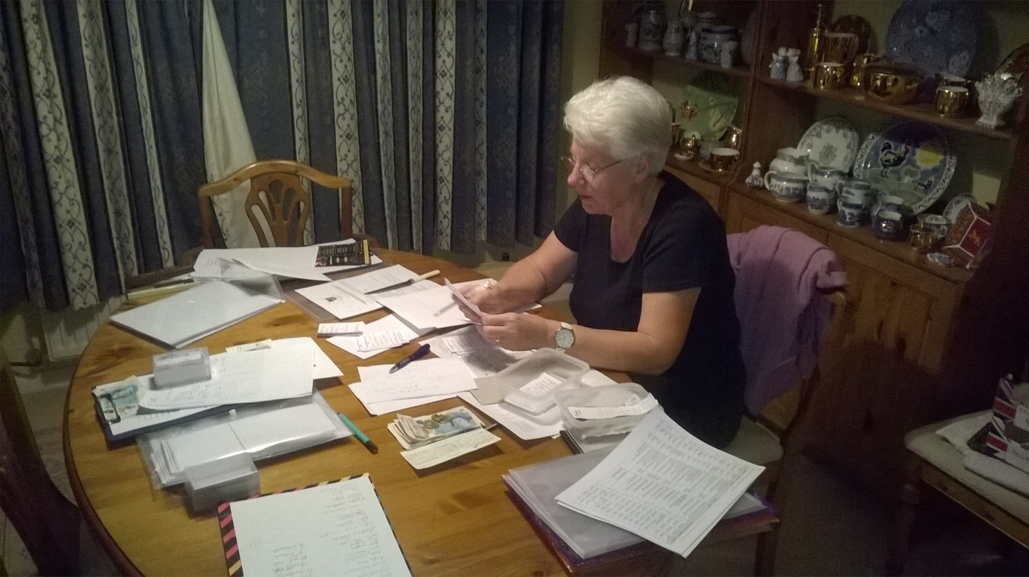

**Our Treasurer and Membership/Events Secretary Christine Shaw balancing five lots of money post AGM!**

**Charles Spencer presents an illustrated talk on his new book *To Catch a King***

**Monday 4th December, The Guild Hall, High Street, Worcester**

We were very excited to welcome Charles Spencer to Worcester, as was Worcester itself. The event was a sell out. 200 people gave Earl Spencer a warm welcome and a rousing round of applause at the end of his presentation. We were all impressed with his knowledge, his willingness both in answering questions, signing books and posing for photographs after the event. Many thanks to his Publicist and Personal Assistant who helped us make this happen.

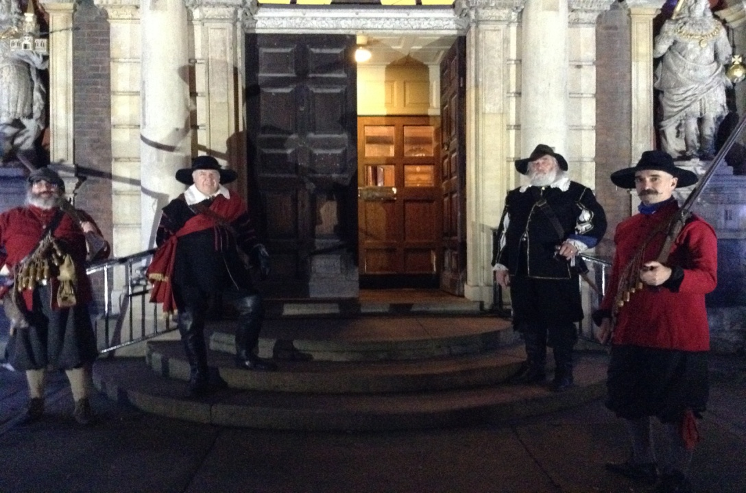**The Welcoming Committee!**

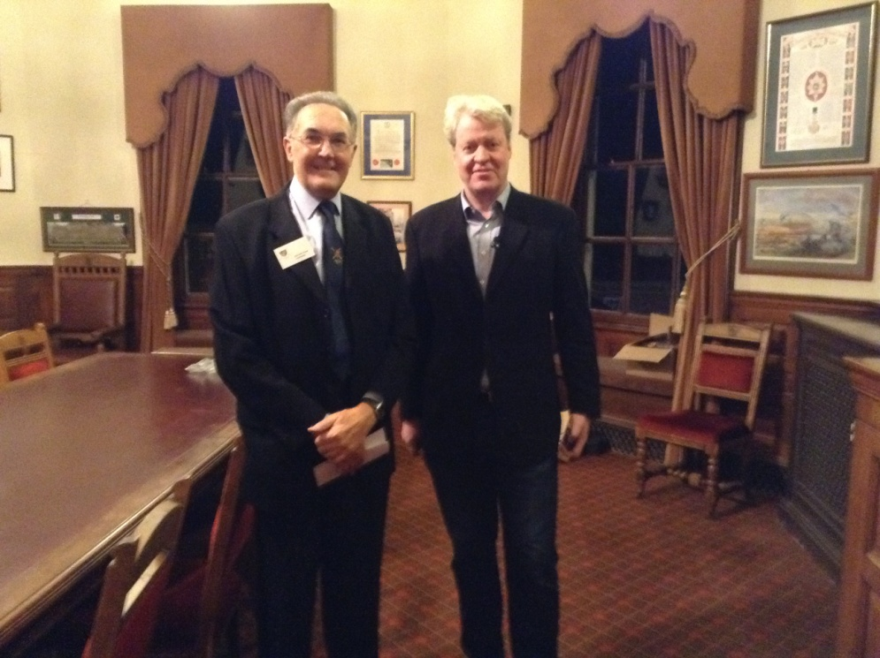 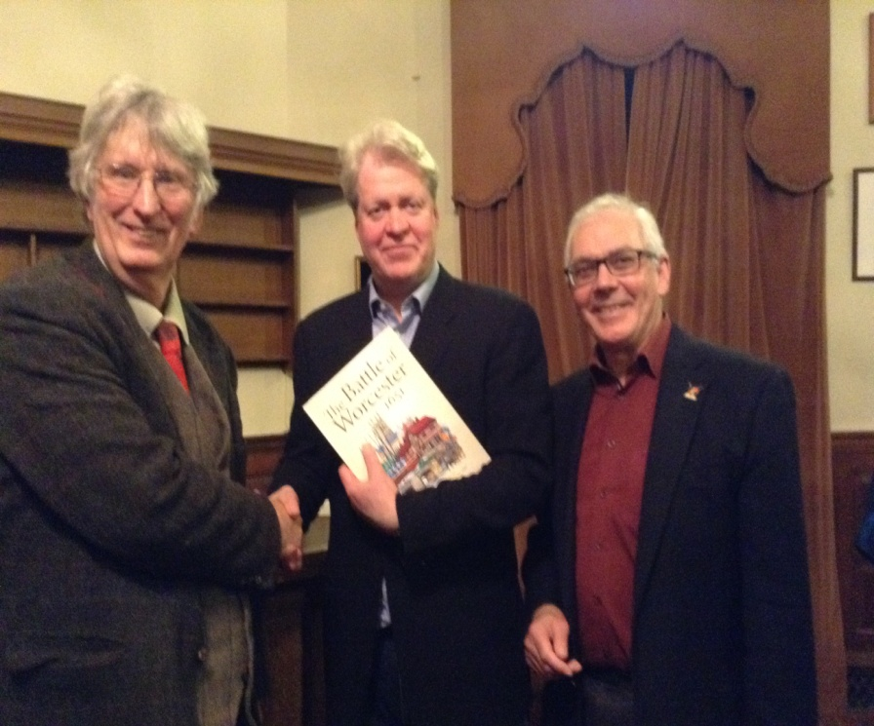

**Earl Spencer and Chairman Richard Shaw Not too sure who the two on the outside are!**

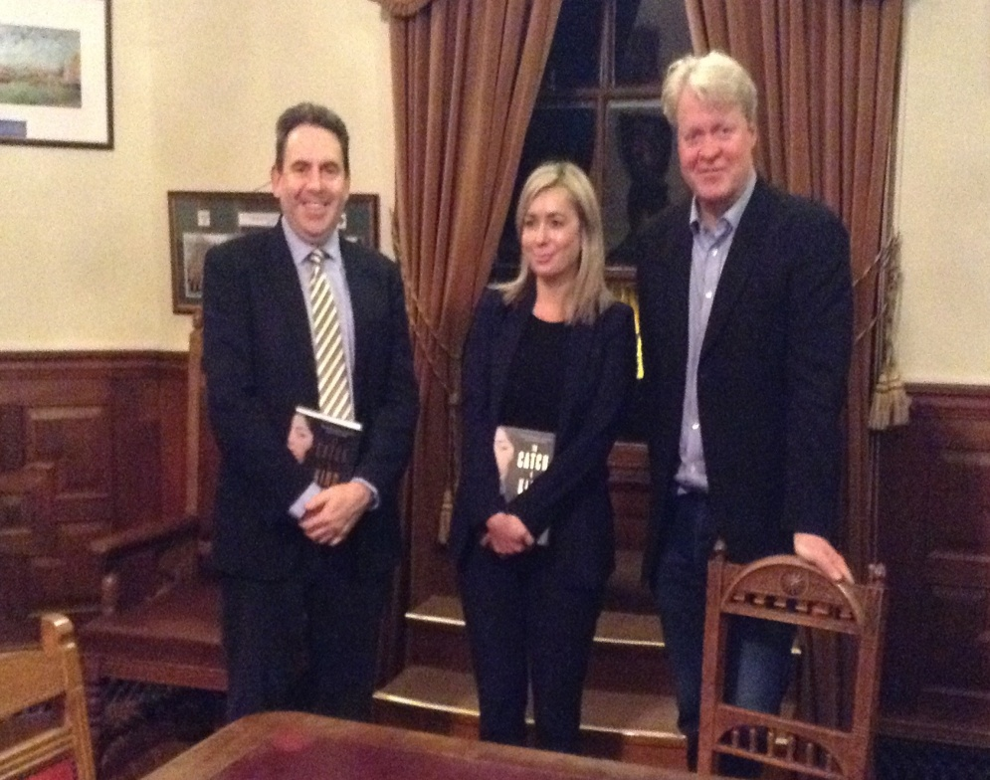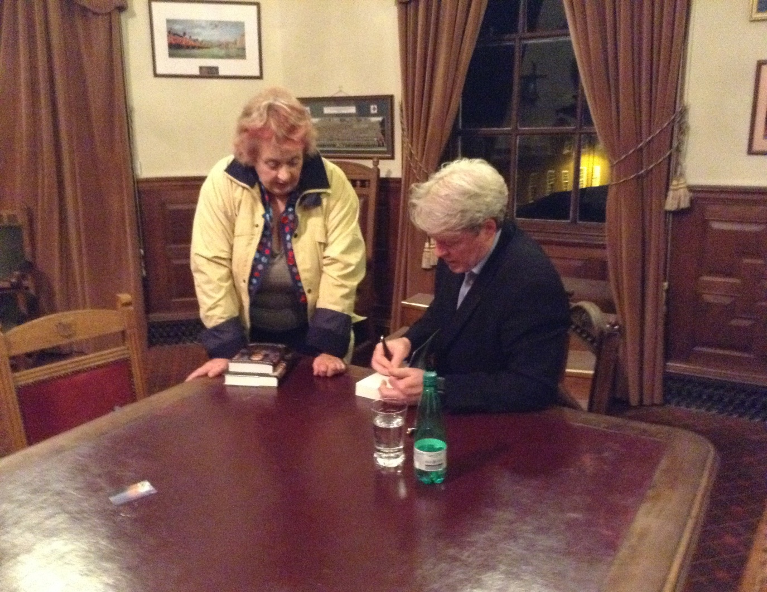

**Earl Spencer and Julian Powell and partner, from New member Helen Cameron with the Earl**

**Event Sponsors Hallmark Hume**

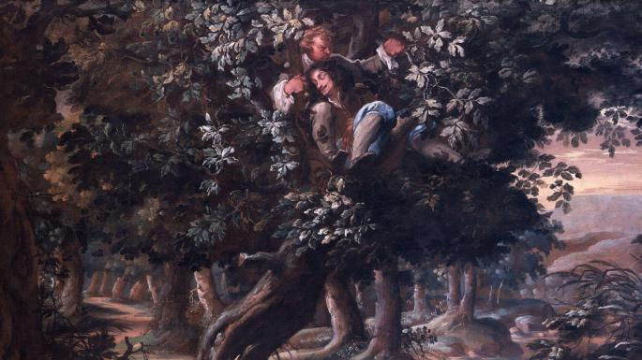

**Christmas Tree Festival 2017 in the Cloister of Worcester Cathedral**

**December, 2017 – January, 2018**

BOWS once again entered a tree in this annual free event which is organised by Worcester Cathedral in association with the Daisy Chain Benevolent Fund. This year the Society was offered a tree by our Sculptor and Fellow Ken Potts, and it was imagined as a symbol of the English Civil Wars. The frame of the aluminium tree was covered with chicken wire. The tree trunks crossed in the middle and then branched out. The left trunk was covered in holly (Royalists) and the right trunk covered in ivy (Parliamentarians). The tree had a Crown which was adorned with holly. The Royalist and Parliamentarians collide in the middle (Battle of Worcester) and go their separate ways. Charles Stuart fled to France. England became a Republic headed by Oliver Cromwell. In 1660 Charles was invited to return to become King Charles II but to rule with Parliament. Charles was crowned on 23rd April 1661 and formally restored to the throne. ‘The holly bears the Crown’.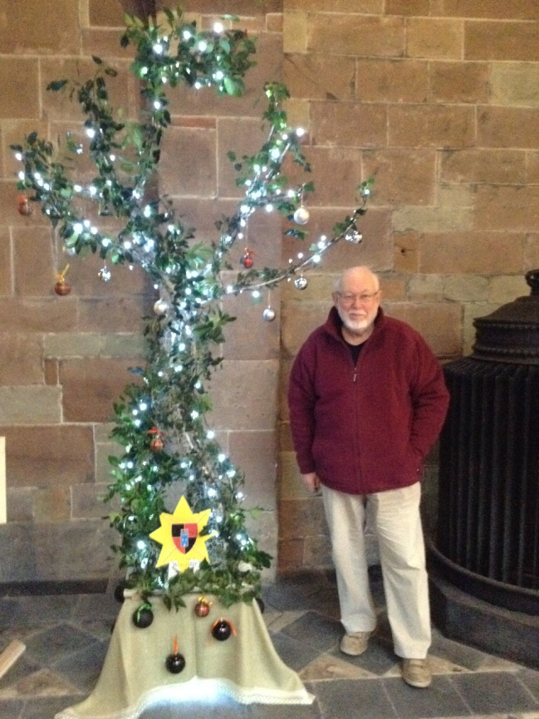

**BOWS Christmas Lunch at The Whitehouse Hotel, Foregate Street, Worcester - Sunday 10th December**

The Whitehouse Hotel maintained last year’s price for the Festive Fayre lunch menu, £22 per person, and up until the morning of Sunday 10 December we had a full house! However, nature had other ideas and the snow was so deep that it meant those Members who did not live locally were unable to attend the lunch. We are so sorry that they missed out as the meal was delicious and we missed their company. After Lunch we held the Grand Christmas Draw.

**Grand Christmas Draw - Sunday 10th December**

I was able to source a GTech Multi hand held cordless vacuum cleaner as the main prize for our Christmas Draw, Ken Potts very kindly donated a maquette of the Adams and Jefferson Statue. Other prizes included a signed copy of the book *To Catch a King*, a delightful cut glass vase and several bottles of alcohol. The prize winners were: First Prize: Colin Johnson (Member), Second Prize: Paul Robbins (Member), Signed Book: Roger Fairman (Member), Chocolates: Joan Parker, Biscuits: David Robinson (Member), Cut Glass Vase: Alexander Shaw (Member), Wine: Linda Robinson, David Cadle, Nicholas Richardson, Grant Simmonds (Member) and A. Dineley.

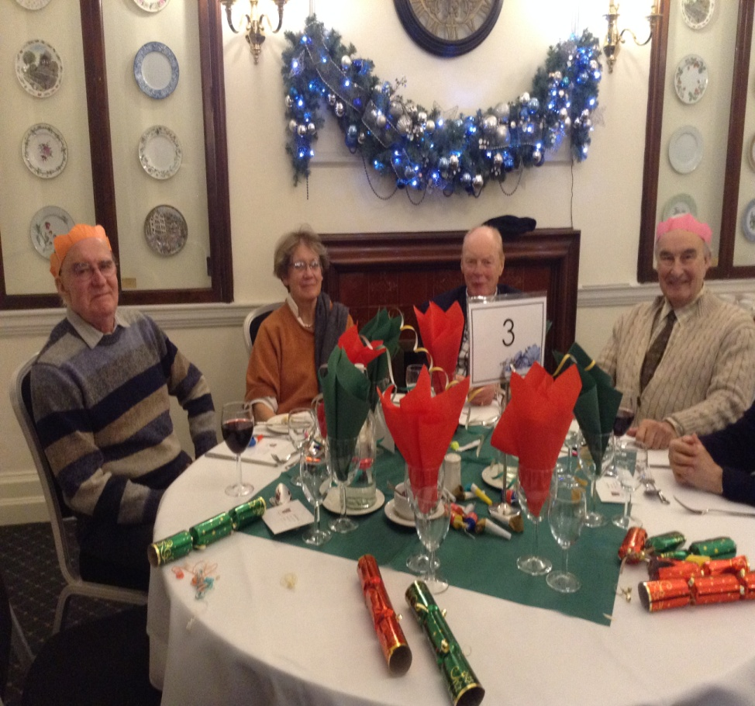

**Grand Competition Winner Colin Johnson on the left at the Christmas Lunch**

**PLANNED EVENTS IN 2018**

We will once again organise a series of Civil War Talks which will probably take place in May, June, July and August. None of the arrangements have been confirmed, but we will let you know what they are as soon as we know.

**ADAMS AND JEFFERSON MONUMENT APPEAL LAUNCH**

The Executive Committee is planning the launch of the Adams and Jefferson Monument Appeal for **Sunday** 8th April, 2018. This date marks the anniversary of Adams’ and Jefferson’s visit to Worcester 232 years ago. John Adams gave a speech on Fort Royal Hill to a considerable crowd of people on this day. He wrote in his diary about that day:

“*The people in the neighbourhood appeared so ignorant and careless at Worcester that I was provoked and asked* ***And do Englishmen so soon forget the ground where liberty was fought for. Tell your neighbours and your children that this is holy ground, much holier than that on which your churches stand. All England should come in pilgrimage to this hill once a year.****”*

Details of the launch have yet to be agreed. We will inform Members and Friends of the Society of the arrangements as soon as we can, but in the meantime –

**PLEASE SAVE THE DATE!**

**R.I.P.**

I am sorry to report that Ray Way, one of our newer members, passed away in November 2017.

**OTHER DATES FOR YOUR DIARY**

**Living History at The Commandery**

**17th February 2018 - 18th February 2018**

**Time:** 10:00 - 17:00

**Cost:** Adults £5.95 Concessions £4.95 Children FREE Individual annual ticket £10.95

Worcester residents annual ticket £5E

Experience 2000 years of history come to life with a weekend of living history encampments, military displays, vintage vehicles and more.

Organised in partnership with Worcester Re-enactors. Part of the Love Worcester Heritage Festival.

Living History in Worcester is part of the Love Worcester Heritage Festival; a week of events in heritage venues across the City from 14th - 25th February 2018.

**CHARLES 1: KING AND COLLECTOR**

**The Royal Academy of Arts, London**

**27 January — 15 April 2018** S**aturday – Thursday 10am – 6pm Friday 10am – 10pm**

Discover the legendary art collection of Charles I. For the first time since the 17th century, this landmark exhibition brings together the astounding treasures that changed the taste of the nation.

King Charles I amassed one of the most extraordinary art collections of his age, acquiring works by some of the finest artists of the past – Titian, Mantegna, Holbein, Dürer – and commissioning leading contemporary artists such as Van Dyck and Rubens.

Following the king’s execution in 1649, his collection was sold off and scattered across Europe. While many works were retrieved by Charles II during the Restoration, others now form the core of museums such as the Louvre and the Prado.

*Charles I: King and Collector* will reunite the greatest masterpieces of this magnificent collection for the first time. Celebrating its breadth and grandeur, over 100 works of art, ranging from classical sculptures to Baroque paintings, and from exquisite miniatures to monumental tapestries are on show. The exhibition will demonstrate the radical impact they had at the time and shed light on how they fostered a vibrant visual culture that was hitherto unknown.

**CHARLES II: ART & POWER**

**The Queen’s Gallery, Buckingham Palace, London**

**Friday, 8 Dec 2017 - Sunday, 13 May 2018**

After over a decade of austere Cromwellian rule, the restoration of the monarchy in 1660 led to a resurgence of the arts in England.  The court of Charles II became the centre for the patronage of leading artists and the collecting of great works of art, which served not only as decoration for the royal apartments but also as a means of glorifying the restored monarchy and reinforcing the position of Charles II as the rightful king.

**PATRONS OF THE SOCIETY**

**His Grace The Duke of Hamilton ▪ Earl Spencer ▪ Lord Faulkner of Worcester ▪**

**Lord Selkirk of Douglas ▪ Sir Robert Worcester ▪The Hon. Lady Rosalind Morrison ▪**

**Mr. Henry Berkeley ▪ Ms. Diane Rapaport ▪**

**Professor Ron Hutton**

**Executive Committee**

**Richard Shaw (Chairman) ▪ Kenneth Potts ▪ Vaughan Wiltshire,**

**Christine Shaw ▪ Roger Fairman ▪ Brian Bullock**

**Trustees**

**Richard Shaw ▪ Vaughan Wiltshire ▪ Jack Randall ▪ Peter Brookes ▪**

**Derek Law ▪ Christine Shaw ▪ Roger Fairman ▪**

**Grant Simmonds ▪ Steve Hunt ▪ Ben Humphrey**

**Monument Appeal**

**Lord Richard Faulkner is Patron of the appeal**

**Black Pear Bulletin Editorial Team**

**Christine Shaw**

**Tel. 01905 358640**

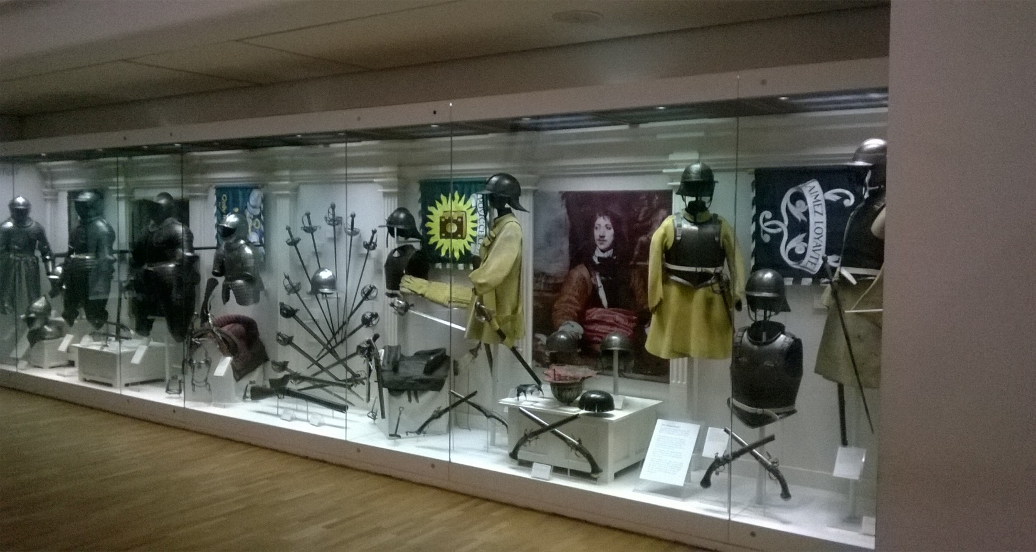

**© The Battle of Worcester Society 2017** [**www.thebattleofworcestersociety.org.uk**](http://www.thebattleofworcestersociety.org.uk)