The Black

Pear Bulletin

*The Newsletter of the Battle of Worcester Society*

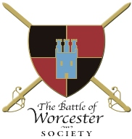Registered Charity Number: 1160010

**Issue No. 20 ~ May 2018**

**OUR CHAIRMAN WRITES**

Spring appears to be struggling to appear in 2018, apart from a few odd days of sunshine, but BOWS keeps moving on! Sunday 8th April 2018 saw the Launch of the Monument Appeal of which details below. I have been busy sourcing more Speakers for our 2018 Season of the Civil War Nights and we are delighted that we have four noted historians. The programme for the talks is also listed below. Looking forward to the Summer of 2018, Worcester Re-enactors will once again have a presence at the Powick Summer Fete on Saturday 21st July and also at M5 on 11th and 12th August, 2018.

**ADAMS AND JEFFERSON MONUMENT APPEAL LAUNCH**

The Launch of the Adam and Jefferson Monument Appeal held on Sunday 8th April 2018 was an enjoyable and successful event. Sixty people attended including the Patron of the Appeal, Lord Richard Faulkner of Worcester, the Mayor and Mayoress of Worcester Steve and Alison Mackay (also BOWS members), past Chairmen of the Society (Grant Simmonds and Andrew Guy whose idea it was to erect a statue to the Presidents), the Chairman of the Civic Society Phil Douce, local Councillors, BOWS Members, and persons interested in local history.

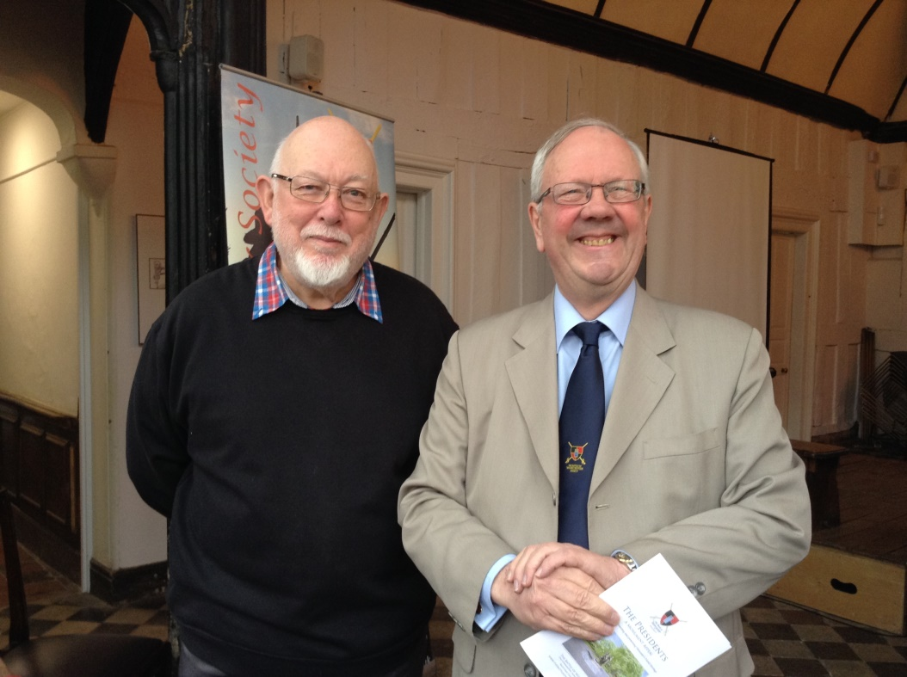

**Patron of the Monument Appeal, Lord Richard Faulkner of Worcester**

**with Sculptor of the proposed statue, Ken Potts**

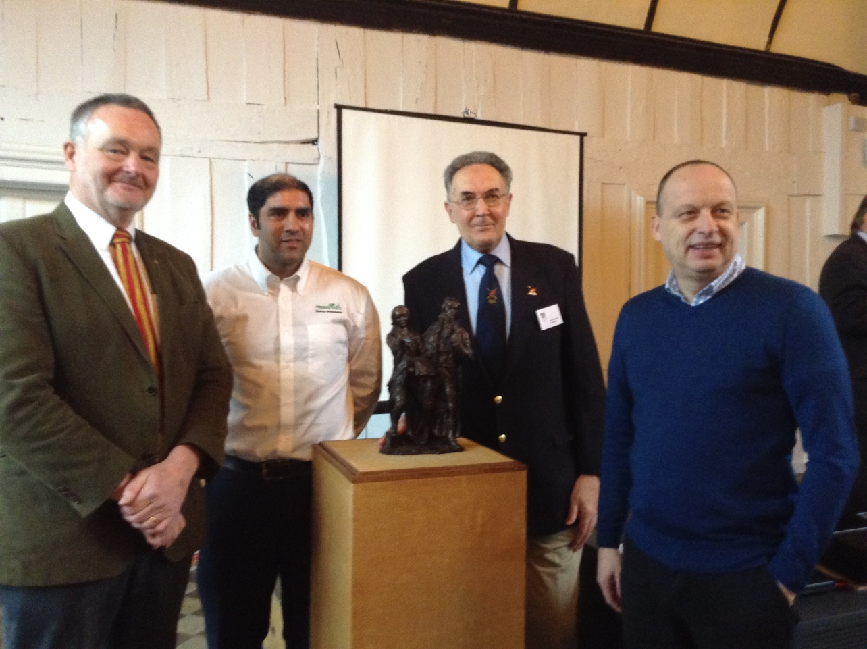

**Chairman of BOWS Richard Shaw together with donors to the Monument Appeal (from the left) Steve Hunt, Managing Director of Spectrum Environmental, Jabba Riaz from Air Products and Phil Dutton, Chairman of the Worcestershire Ambassadors**

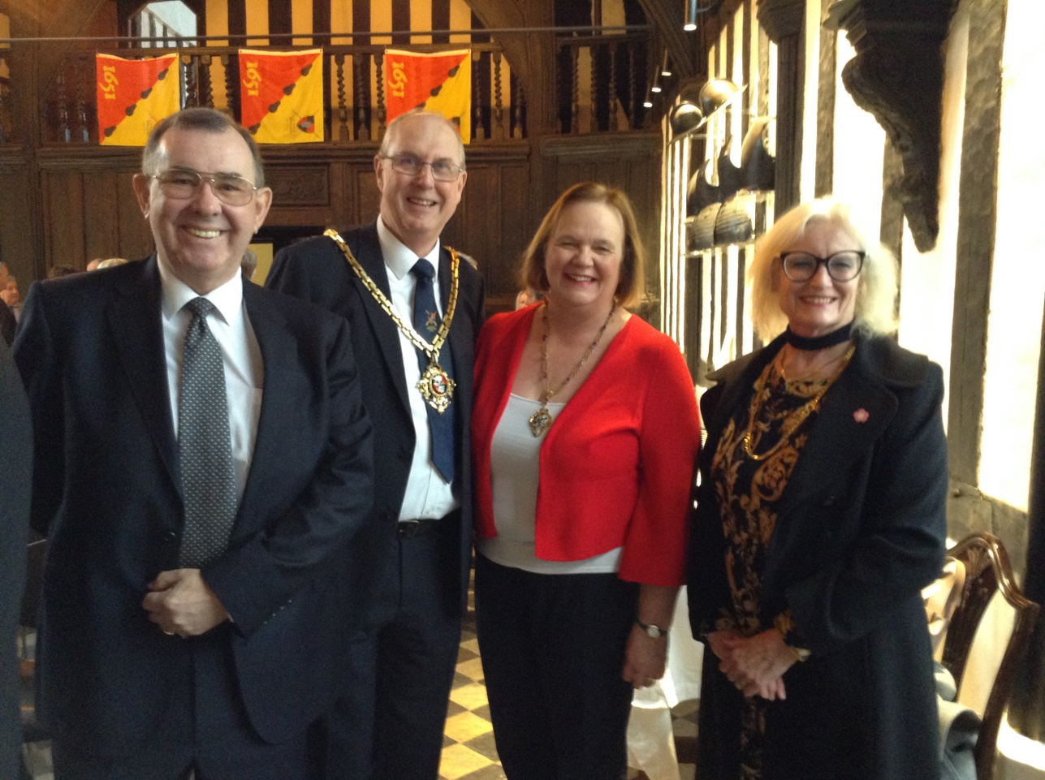

**Mayor Steve Mackay with Mayoress Alison Mackay (also BOWS members) and new members to the Society**

**John and Lorna Eden**

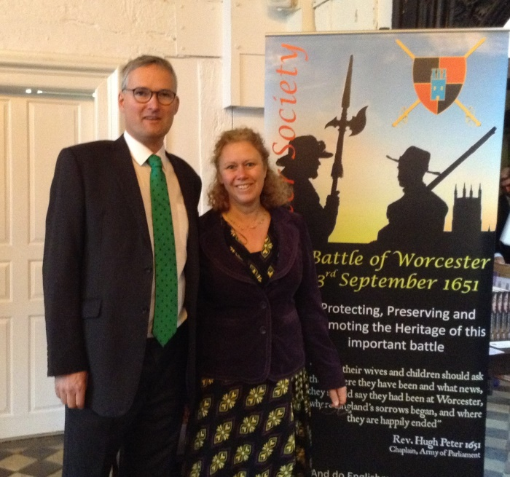 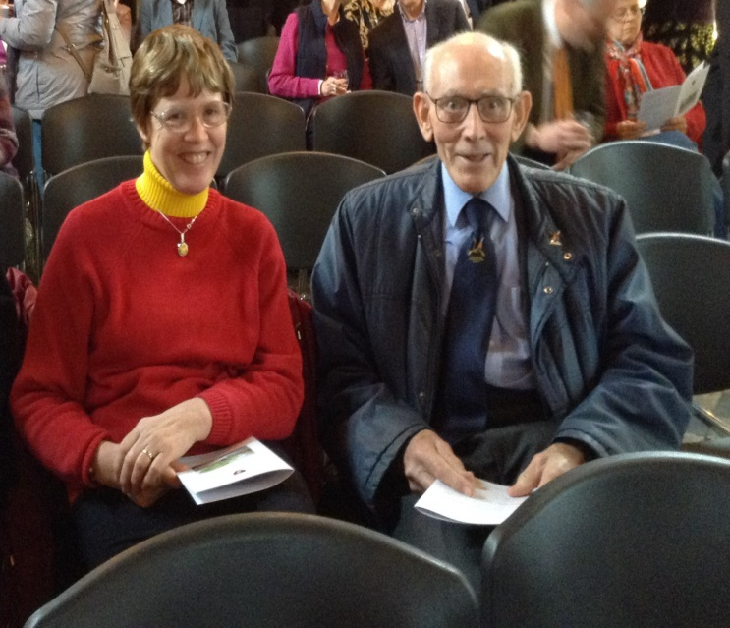

**Local Councillor Louis Stephen and wife Kate BOWS members Sue Fairman and Arthur Burgess**

The Launch was opened and introduced by the Appeal’s Patron, Lord Richard Faulkner of Worcester who remarked that …………………….. Lord Faulkner’s introduction was later followed by my presentation on the links between Adams and Jefferson and Worcester. The links between John Adams and Worcester in particular are many. If you would like a copy of the presentation emailed to you please get in touch with the Membership Secretary who can arrange it. Thank you to The Commandery for the use of The Great Hall and thank you also to Commandery Coffee for a delicious buffet. Following the launch, the Monument Appeal Fund now stands at £15,000. If you would like to donate to the fund – and we hope you do - details can be found on the Society’s website.

**CIVIL WAR NIGHTS 2018**

I am delighted to report that we have four excellent speakers to give presentations to the Society. The dates are as follows:

**Thursday 10th May 7pm The Commandery**

Professor Martyn Bennett, Nottingham Trent University

***Cromwell in Ireland***

**Thursday 7th June 7pm The Commandery**

Professor Darren Oldridge, Worcester University

***The Supernatural in the English Civil War***

**Thursday 12th July 7pm The Studio, The Hive**

**PLEASE NOTE DIFFERENT VENUE**

Professor Anne Laurence, Open University

***Every Day Life in the Civil War***

**Thursday 2nd August 7pm The Commandery**

Lucy Moore, Author and Historian

***Lady Fanshawe’s Receipt Book - The Life and Times of a Heroine of the English Civil War***

Commandery Coffee opens at 6.00 p.m. and the presentation begins at 7.00 p.m.

The café at THE HIVE is open all day and doors to the Studio will be open at 6.30 p.m. but there are plenty of things to see in the Library should you arrive earlier.

**ANNUAL GENERAL MEETING**

For the last few years the Annual General Meeting has been held in the month of November. Our financial year runs from January to December. This means that two sets of accounts have to be prepared, one for November and one for December. The Executive Committee discussed this at length and it has decided to change the date of the AGM. Our constitution dictates that one AGM can be held up to fifteen months after the last one. Therefore it has been decided to hold the next AGM in February/March 2019. This will enable one set of accounts to be prepared and in sync. The accounts will also be ready for the Honorary Secretary of the Trustees Vaughan Wiltshire, to submit them to the Charity Commission in June.

**DRUMHEAD SERVICE 2018**

The Drumhead Service is held traditionally on 3rd September each year to commemorate those who died in battle at Worcester in 1651. The Parade to the Service starts at The Commandery and the march up Fort Royal Hill culminates in a service in memoriam commencing at 7.00 p.m.

However, things have changed this year. The Commandery does not open on a Monday although the Curator, David Nash has kindly offered to open it especially for BOWS. In addition, the Cromwell Association, which also meets every 3rd September to commemorate the death of Oliver Cromwell at the Palace of Westminster have been told that the area will be a building site. BOWS has been approached by the Cromwell Association to join forces for both events on 1st September and this has been agreed.

During the day the Cromwell Association will mark the occasion with a service at The Cathedral but at 5.30 p.m. we will all gather together at the Guildhall to meet the Mayoral Party for a Parade through the streets of Worcester to the Commandery. As usual The Cardinal’s Hat will set up a bar in the Great Hall, and later Canon Michael Brierley will conduct the service on Fort Royal Hill.

**BATTLE OF WORCESTER HERITAGE PARTNERSHIP PROJECT**

The Heritage Partnership Project is an amalgamation of all parties who have an interest in the battle such as: The Battlefield Trust, The Cromwell Association, The Sealed Knot, The Commandery, The Cathedral, Worcester City Council and of course BoWS.  They meet quarterly in the Guildhall and former BoWS Chairman, Grant Simmonds is the Chairman.

An unconfirmed date for the unveiling of the information boards at the confluence of the rivers Teme and Severn, showing the Parliamentarian Bridges of Boats to cross these two rivers during the Battle of Worcester is Sunday 2nd September, 2018. This will enable those of the Cromwell Association who have stayed overnight to take part in the ceremony.

**DATES FOR YOUR DIARY**

**CIVIL WAR NIGHTS**

***Full programme of events is in the body of this newsletter***

First event is on Thursday 10th May 2018

**THE WITCH: A HISTORY OF FEAR FROM ANCIENT TIMES TO THE PRESENT**

Chipping Campden Literature Festival

Wednesday 9th May, 2018 at 10 a.m. Upper Room Town Hall £7

Professor Ron Hutton, Patron and one of our favourite speakers examines attitudes on witchcraft and the treatment of suspected witches across the world …

Professor Hutton has a recently published book *The Witch* to accompany the talk.

**CHARLES II: ART & POWER**

**The Queen’s Gallery, Buckingham Palace, London**

**Friday, 8 Dec 2017 - Sunday, 13 May 2018**

After over a decade of austere Cromwellian rule, the restoration of the monarchy in 1660 led to a resurgence of the arts in England.  The court of Charles II became the centre for the patronage of leading artists and the collecting of great works of art, which served not only as decoration for the royal apartments but also as a means of glorifying the restored monarchy and reinforcing the position of Charles II as the rightful king.

**Powick Village Fete**

Saturday 21st July, starting at 2.00 p.m.

At Powick Church, Worcestershire

**M5**

Saturday 11th and Sunday 12th August, 2018

Spetchley Park 10.00 a.m. – 5.00 p.m.

<http://www.worcesterreenactors.uk/m5/>

**PATRONS OF THE SOCIETY**

**His Grace The Duke of Hamilton ▪ Earl Spencer ▪ Lord Faulkner of Worcester ▪**

**Lord Selkirk of Douglas ▪ Sir Robert Worcester ▪The Hon. Lady Rosalind Morrison ▪**

**Mr. Henry Berkeley ▪ Ms. Diane Rapaport ▪**

**Professor Ron Hutton**

**Executive Committee**

**Richard Shaw (Chairman) ▪ Kenneth Potts ▪**

**Vaughan Wiltshire ▪**

**Christine Shaw (Treasurer and Membership Secretary) ▪**

**Roger Fairman ▪ Brian Bullock**

**Trustees**

**Richard Shaw (Chairman) ▪ Vaughan Wiltshire (Honorary Secretary)▪**

**Jack Randall ▪ Peter Brookes ▪ Derek Law ▪ Christine Shaw ▪**

**Roger Fairman ▪ Grant Simmonds ▪ Steve Hunt ▪ Ben Humphrey**

**Monument Appeal**

**Lord Richard Faulkner is Patron of the appeal**

**Black Pear Bulletin Editorial Team**

**Christine Shaw**

**Tel. 01905 358640**

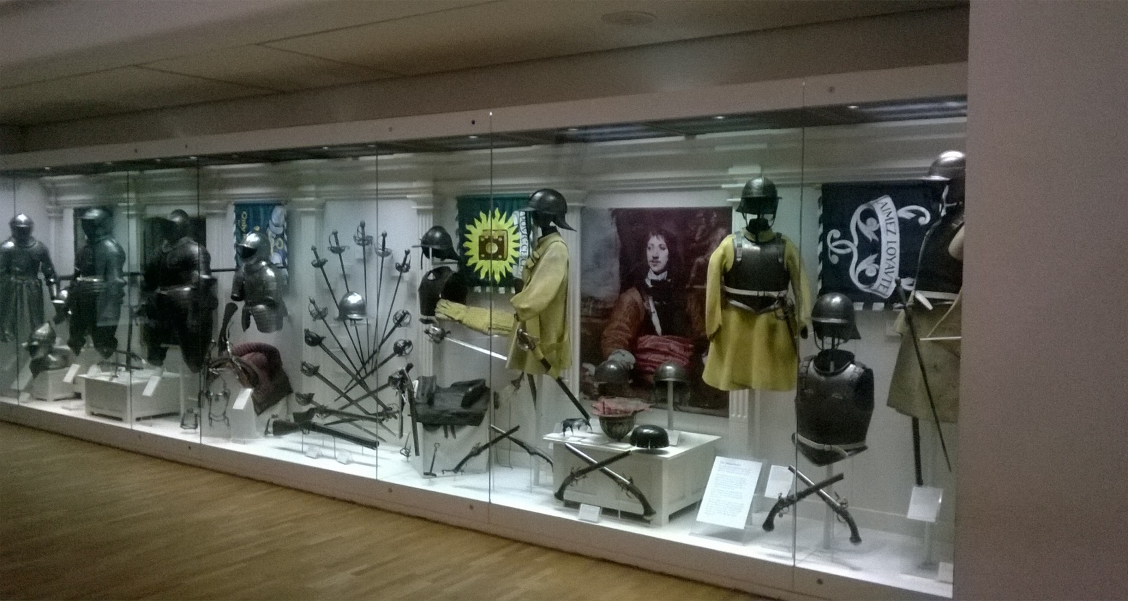

**© The Battle of Worcester Society 2017** [**www.thebattleofworcestersociety.org.uk**](http://www.thebattleofworcestersociety.org.uk)