The Black

Pear Bulletin

*The Newsletter of the Battle of Worcester Society*

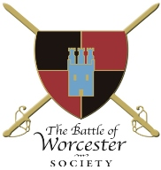Registered Charity Number: 1160010

**Issue No. 21 ~ Autumn/Winter 2018**

**OUR CHAIRMAN WRITES**

All of our Civil War Nights have been a success and we have pleasure in extending the Civil War Nights’ season to accommodate Welsh born Australian member A J Lyndon who wishes to tell us about her new book *The Welsh Linnet*. Further details are included in ‘Dates for your Diary’.

The Clan Fraser Society of Scotland and the UK wrote to me earlier this year requesting a visit to Worcester and a dinner. Thanks to catering information from Brian Bullock and help from Sarah Bourne at The Commandery I have organised a private 17th Century Banquet in The Great Hall of The Commandery on Saturday 18th August, 2018. 800 Frasers were part of the Royalist Army at the Battle of Worcester and the Clan Fraser Society wish to see where their ancestors fought. Raconteur Howard Robinson is going to give them a presentation on the battle, although there is no definitive historical evidence as to where the 800 Frasers fought, but only two of them made it back to Scotland.

After years of me badgering them, the battlefield tour company *Cultural Experience* now includes Worcester and the English Civil Wars on one of its tours. They visited Powick Bridge and Worcester on 5th July and I gave them a tour of The Commandery, Fort Royal Hill and The Cathedral. *Cultural Experience* intends to return in 2020 to explore the Battle of Worcester.

**CIVIL WAR NIGHTS 2018**

As stated above, I am delighted to report that our Civil War Nights’ presentations were very well attended. The first talk given by Professor Martyn Bennett of Nottingham Trent University on ***Cromwell in Ireland*** attracted an audience of 60, as did the talk by our local Professor, Darren Oldridge of Worcester University who lectured us on ***The Supernatural in the English Civil War.*** We had to change venue for Professor Anne Laurence’s talk, *Hearing Women’s voices during the English Civil Wars* to the Hive as Worcester Live were putting on their summer play T*he Hound of the Baskervilles* in the Commandery Gardens (starring Society President Ben Humphrey), and the result of that change of venue was a smaller audience than we have been used to. Finally, back at The Commandery, delightful author and historian Lucy Moore entertained us royally, on her book ***Lady Fanshawe’s Receipt Book - The Life and Times of a Heroine of the English Civil War.***

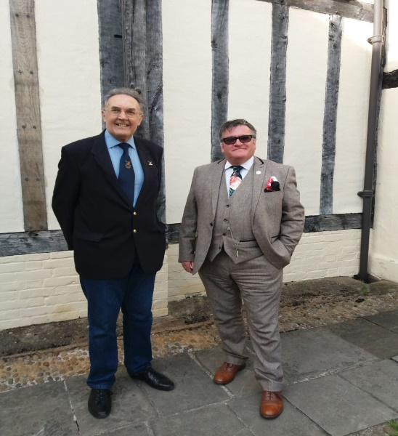

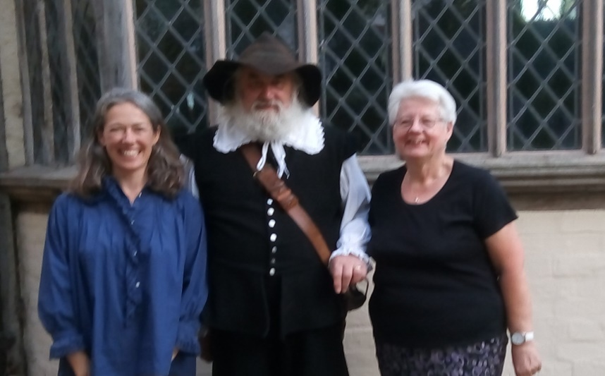

*Chairman with Professor Martyn Bennett Lucy Moore with Brian Bullock and Christine*

**ADAMS & JEFFERSON MONUMENT UPDATE**

We have reached £15,000, thank you to everyone who has donated … so far.

**TREASURER RESIGNS**

Christine Shaw (my wife) who is Treasurer, Membership Secretary and Events Secretary and my right hand help has made the decision to resign from her post as Treasurer which she has held for six years. Christine feels that the role of Treasurer has expanded and will expand more as the appeal towards the Presidents’ Monument fund grows. The job on its own is very straightforward as the accounting is a standard procedure, but whilst performing her other roles she cannot devote the time she thinks the post of Treasurer deserves. The Treasurer is also responsible for providing cash floats for events, taking charge of the merchandise, banking monies and liaising with the Chairman. Christine will not leave her post until 31st December 2018. As the Society is a Charity we are hoping that more funds will come into the Monument Account via fund raising events and Gift Aid. She is aware that everything we do must be done with transparency. Having a husband and wife as signatories to the accounts may not be in those interests. I would be grateful for anyone who is interested in taking over the role in 2019 to contact me on 01905 358640 or by email: [richardshaw99@live.co.uk](mailto:richardshaw99@live.co.uk)

**PRESIDENT BEN HUMPHREY**

Ben, who has been associated with the Society for many years, as a Member, a successful Chairman and our First Honorary President, is leaving Worcester for pastures new. He begins a new position with the National Trust Scotland as their Events Officer, a post we think he will fill admirably. We all wish Ben success in his new venture.

**CHRISTMAS TREE FESTIVAL**

Following an appeal to the Membership for help with the Christmas Tree Festival, Society member Mr Leslie Davies and his wife Barbara have volunteered to take on this project for 2018. Thank you both so much!

**Date for Your Diary - Our Christmas Lunch will be at The Whitehouse (Foregate Street not Pennsylvanian Avenue) on Sunday 9th December 2018, full details nearer the date.**

**CIVIL WAR STORIES**

This play created by Ruth Richardson; was contributed to and performed by Jonathan Darby and Claire Worboys. It was produced by Gemma Dhami, designed by Emma Thompson and presented by The Commandery on Sunday 27th May, 2018. It was an outstanding telling of the Battle of Worcester story and suitable for all ages. We are hoping to weave a members’ social event around this play in the near future. We will keep you posted.

**DRUMHEAD SERVICE AND CROMWELL DAY**

**Saturday 1 September 2018 - FREE EVENT**

**The Battle of Worcester Society is hosting a joint event to commemorate those who died on 3rd September 1651.**

The Cromwell Association has its own events during the day but will join the Society at:-

**5.00 p.m. The Guildhall, High Street, Worcester**

when a parade led by the Worcester Re-enactors, the Mayor, Councillor Jabba Riaz and his Mayoral Party, Chairman of the Society Richard Shaw and BoWS and Cromwell Association members and members of the public, will make its way to The Commandery

**5:30 p.m.** The Great Hall where the Cardinal’s Hat will have set up a 17th century bar

**6:45 p.m.** Parade from Commandery to Fort Royal Hill

**7.00 p.m.** A Cannon will fire on Fort Royal Hill; Introduction by BoWS Chairman; Service by Canon Michael Brierley; a few words from the Cromwell Association President; Re-enactors to fire musket volleys to mark the beginning and end of one minute’s silence.

**7.30 p.m**. Process back to the Commandery

**UNVEILING OF INFORMATION BOARDS AT THE CONFLUENCE OF THE RIVERS SERVERN AND TEME**

**Sunday 2nd September, 2018 a BATTLE OF WORCESTER HERITAGE PARTNERSHIP PROJECT**

**FREE EVENT**

The Heritage Partnership is an amalgamation of all parties which have an interest in the battle such as: The Battlefields Trust, The Cromwell Association, The Sealed Knot, The Commandery, The Cathedral, Worcester City Council and of course BoWS.  They meet quarterly in the Guildhall and former BoWS Chairman, Grant Simmonds is the Chairman. Their project to provide an Information Board to mark the site of the two Bridges of Boats at the confluence of the rivers Teme and Severn has come to fruition.

The timetable is:-

**10.30 a.m.** **The Ketch Viewpoint** Tony Spicer will give a talk on the Battle of Worcester making specific reference to the tactical importance of the Bridges of Boats. If the weather is fine it may not be possible to find a parking space at the Viewpoint as the Boot Sale in the field opposite is extremely popular.

**11.30 a.m**. Mr Cecil Duckworth will unveil the Information Board situated on the east riverbank opposite the confluence. Access to the confluence of the rivers is via the public footpath which runs along the east bank of the River Severn. The manager of the Ketch Caravan Park has given members of The Society and The Association permission to park in the car park which is on the A38 next to B and M Bargains/Aldi on one side and The Ketch public house (Toby Carvery) on the other. There will then be a walk down a steepish hill, turn right through the caravan park (public footpath) to the site of the information boards.

**BATTLE OF WORCESTER RUN – “Crossing Rivers”**

**Monday 3rd September, 2018 367th Anniversary of the Battle of Worcester**

**FREE EVENT**

**Start 7.00 p.m**. Meeting at the Civil WarViewpoint (more familiarly known as The Ketch Viewpoint), just east of the Carrington Bridge. There are five legs to the run and at each of the five points a short talk will be given about the history at that point. Talks will last about one minute each. The run is 7,000 metres long. Other runners are welcome to join in. Not a race, it is a running history tour, see you there?

**CIVIL WAR NIGHTS’ SEASON 2018 EXTENDED!**

**Thursday 6th September, 2018**

**The Welsh Linnet** – a talk by A J Lyndon

Doors open 6.00 p.m. Refreshments from Commandery Café. Talk begins at 7.00 p.m. Tickets £5

Australian Society member and historical novelist A J Lyndon – known to us as Felicity Goldstein - will be in the UK during the month of September. Her trip has been arranged to coincide with the Drumhead Service as she is seriously interested in the English Civil Wars. A J Lyndon is going to give a presentation on her recently published novel *The Welsh Linnet* which is the first of a trilogy, the final one of which will feature the Battle of Worcester.

She will talk about the historical inspiration for her first book, *The Welsh Linnet* and the research undertaken to write about the English Civil Wars. This book is the first of three; the final one will feature the Battle of Worcester.

**R.I.P. RICHARD RAND**

Richard passed away whilst on holiday with his wife Robina, on the Isle of Barra, Scotland. Richard was not only a staunch supporter of the Society but he also fulfilled the role of Church Warden at Ripple Church where the Sealed Knot holds its annual Founder’s Day memorial service. He will be missed by so many.

**-ooo000ooo-**

**OTHER DATES FOR YOUR DIARY**

**GLOUCESTER HISTORY FESTIVAL**

**Saturday 1 September – 16th September 2018**

Interesting Civil War talks …

[**https://www.gloucesterhistoryfestival.co.uk/events?blackfriarstalks=true&page=1**](https://www.gloucesterhistoryfestival.co.uk/events?blackfriarstalks=true&page=1)

**EXTRAORDINARY COMMANDERY WOMEN**

FREE Entry as part of the Heritage Open Days Festival at The Commandery, Sidbury, Worcester  
**Sunday 16th September, 1.30 – 5pm**

For Heritage Open Days only, learn about the extraordinary women who have lived at The Commandery through special costumed tours. From getting to know Georgian gentry life with Letitia Dandridge to discovering the role of Ann Wylde and the Wylde family together with women in the 1646 siege of Worcester. There are many fascinating stories to tell. You can also visit The Commandery's new interactive exhibition for free - discover the clash of Royalist and Parliamentarian beliefs in the former Royalist battle headquarters from 1651 and experience a pivotal moment in English history.

**BATTLE OF WORCESTER WALK**

**JOINT BATTLEFIELD TOUR – Battlefields Trust and the Battle of Worcester Society**

**SATURDAY 28th SEPTEMBER 2018**

**Morning Tour by Car:** Meet at 1030 a.m. at The Ketch Viewing Point (off junction A4440/A38T)

**Lunch Stop:** Manor Farm Pub,Malvern Road, Worcester WR2 4BS with display of artefacts: touch and feel history!

**Afternoon Walking Tour:** Meet 2.30 p.m. outside The Commandery, Sidbury, Worcester WR1 2HU for a 1-2 mile walk. This is a unique event organised by Accredited Battlefield Guide Anthony Rich linking two but separate tours of this famous battle. Further details will be forwarded to members in September, 2018.

**HOWARD ROBINSON HISTORY TALKS**

**18th September, 25th September, 2nd October, 2018**

Henry Sandon Hall, Worcester. This is **not** a BOWS event. Howard’s three talks are entitled:

King John and Magna Carta

Where England's Sorrows Began and Where they are Happily Ended

Oliver Cromwell and his Contribution to our Modern Democracy

Full details of venue, times and costs can be found here:

**http://www.worcesterlive.co.uk/events_review.asp?eid=453061131**

**CREATIVE WRITING WORKSHOP**

**Saturday 6th October 2018 - 10.30 a.m. - 1.30 p.m.**

**The Commandery, Sidbury, Worcester**

**Cost: £20 per person.**

Local writer Sue Johnson is donating a Creative Writing Workshop in aid of the **A & J Monument Appeal.**  Sue is published as a poet, short story writer and novelist and is a Writing Magazine Home Study Tutor.  (Further details of her work can be found at [www.writers-toolkit.co.uk](http://www.writers-toolkit.co.uk)). The workshop will be held in The Commandery, Sidbury, Worcester and is open to all writers from beginners to the more experienced. The fee includes tea, coffee and home-made cake. I am going to give it a go. I hope many of you will join me for what promises to be an interesting and enjoyable morning which will also help the Monument Appeal Fund.

Please ring Christine on 01905 358640 or email her on [seashells84@sky.com](mailto:seashells84@sky.com) to book your place. Payment can be made in advance by cheque made out to T*he Battle of Worcester Society* or on the day by cash or cheque.

**THE MALVERN FESTIVAL OF MILITARY HISTORY**

**5TH – 7TH October, 2018**

The Malvern Festival of Military History has a broad military and naval history theme and will cover subjects ranging from Agincourt to modern day Afghanistan, including the English Civil War. It is at the Hanley Castle home of Nick Lechmere..

[**https://www.enlightenmentevents.com/events/the-malvern-festival-of-military-history/**](https://www.enlightenmentevents.com/events/the-malvern-festival-of-military-history/)

History of the Black Pear  
The iconic Worcester Black Pear appears today in places such as the city coat of arms, the County Council crest and the cricket and rugby club badges, whilst an image of the pear blossom was borne as a badge by the Worcestershire Yeomanry Cavalry until 1956. The earliest reference to any pear associated with a crest is in relation to the Worcestershire Bowmen, depicting a pear tree laden with fruit on their banners at the battle of Agincourt in 1415. Drayton’s poem of Agincourt mentions the fruit, where it is referred to as the badge of Worcester: “Wor’ster a pear tree laden with its fruit”.  
Tradition has it that during the visit of Queen Elizabeth I to Worcester in 1575 she saw a pear tree laden with black pears, which had been moved from the gardens at White Ladies and re-planted in her honour by the gate through which the queen was to enter the city. Noticing the tree Elizabeth is said to have directed the city to add three pears to its coat of arms.  
The Worcester Black Pear may originally have been introduced into the country by the Romans and was first recorded from Warden Abbey in Bedfordshire in the 13th Century. It is the oldest surviving cultivar of pears of its type, a group to which the name ‘warden’ or ‘wardon’ pears was given. It is possibly the same cultivar as the French pear ‘de Livre’.  
Worcestershire history and place names are littered with references to pears, indicating their past cultural and economic importance to the region. The counties of Worcestershire, Herefordshire and Gloucestershire were the focus of pear introduction to England by the Normans and they have been cultivated ever since. Seedlings from the original trees gave rise to specific varieties for eating, cooking and the production of perry.  
Black Pear Trees and their cultivation  
Large Worcester Black Pear trees are distinctive within the landscape, growing up to 50ft (15m) tall with a long, relatively narrow crown. The ageing bark has a square checkerboard pattern and in spring the trees are covered with a cascade of white blossom. They are found scattered across the county in old orchards, hedgerows and gardens, often being planted on the windward side of orchards or fields to provide shelter. The trees were commonly grafted onto wild pear rootstock which made them very vigorous, hence the great height they achieved.  
Whilst the Black Pear is not now grown commercially it has numerous characteristics to recommend it for this: it is easily cultivated, needs little attention, does well on most soils and has a long life span, good disease resistance and prolific fruit bearing capacity. They also have a pleasing and impressive appearance and their stature makes them suitable for use as a nurse crop or shelter for other orchard trees.  
Throughout the 1990s and 2000s Worcestershire County Council made black pears available through its Fruit Trees for Worcestershire scheme and several hundred young trees were planted. Now available from local nurseries on a quince rootstock it can be grown as a smaller tree so making it better suited to gardens and other small sites.  
The Fruit  
The Black Pear is a cooking or culinary pear which is oval and irregular in shape. Individual fruits can be up to 78mm (3″) wide and 85mm long, weighing as much as 260g. They have a dark mahogany colour (not true black) with russet freckles and small areas of rough skin. The flesh is a pale yellow or cream, tinged green under the skin. A common mistake is to pick the fruit in October or early November and to try to use it immediately, when it is crisp, hard and gritty. They should instead be stored until January and will then keep until April. It was this quality of keeping through the winter without refrigeration that once made them so valuable. Various varieties of Warden pears were supposedly transported with the troops as part of their food provisions because of their long lasting properties.  
How to cook a Black Pear  
As far back as the 13th Century the wardon pear was a baking pear of great repute and was for centuries a favourite for inclusion in pies and pastries, described in every early cookery book. In early literature the warden was considered a distinct type of fruit and lists of fruit varieties included both pears and wardens. Wardon pears in syrup were served in the same course as venison, quail, sturgeon, fieldfare and other high quality dishes. Recipes from a 1450 cookery book include meat and fish cooked with pears, leeks, small onions or garlic sauce.  
Hot baked wardens:  
6 large firm pears  
½ – ¾ pint / 300 – 450ml red wine  
1oz / 28g brown sugar  
Pinch of ground cinnamon, ginger and saffron  
Peel the pears and place in an oven proof dish. Mix the red wine with the brown sugar and spices and pour over the pears. Bake in the oven at 180 C / 350 F / Gas Mark 4 until tender (this can be up to 2 hours in the case of black pears).

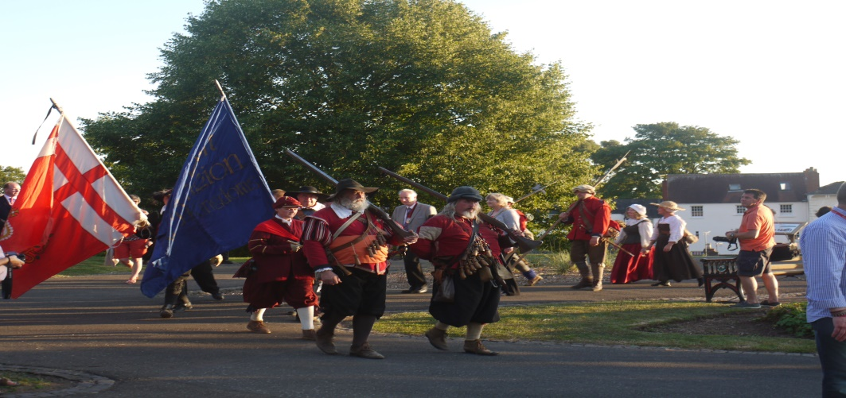

**PATRONS OF THE SOCIETY**

**His Grace The Duke of Hamilton ▪ Earl Spencer ▪ Lord Faulkner of Worcester ▪**

**Lord Selkirk of Douglas ▪ Sir Robert Worcester ▪The Hon. Lady Rosalind Morrison ▪**

**Mr. Henry Berkeley ▪ Ms. Diane Rapaport ▪**

**Professor Ron Hutton**

**Executive Committee**

**Richard Shaw (Chairman) ▪ Kenneth Potts ▪**

**Vaughan Wiltshire ▪**

**Christine Shaw (Treasurer and Membership Secretary) ▪**

**Roger Fairman ▪ Brian Bullock ▪ Geoff Yapp**

**Trustees**

**Richard Shaw (Chairman) ▪ Vaughan Wiltshire (Honorary Secretary)**

**Jack Randall ▪ Peter Brookes ▪ Derek Law ▪ Christine Shaw**

**Roger Fairman ▪ Grant Simmonds ▪ Steve Hunt ▪ Ben Humphrey ▪ Jabba Riaz**

**Monument Appeal**

**Lord Richard Faulkner is Patron of the Appeal**

**Black Pear Bulletin Editorial Team**

**Christine Shaw**

**Tel. 01905 358640**

[**www.thebattleofworcestersociety.org.uk**](http://www.thebattleofworcestersociety.org.uk)