The Black

Pear Bulletin

*The Newsletter of the Battle of Worcester Society*

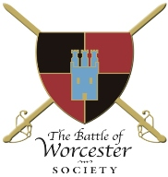Registered Charity Number: 1160010

**Issue No. 22 ~ Winter 2018/19**

**OUR CHAIRMAN WRITES**

A Happy New Year to all our members and readers! 2018 was a busy and successful year in terms of events which were of interest to both Society Members and the public. Interest in the Society is growing and we aim to build upon that in the coming year. This Bulletin will give a brief summary of events which occurred during the latter part of 2018 and also provide you with details of happenings in 2019.

**BRIDGES OF BOATS INFORMATION BOARD**

On 2 September, 2018 the project led by the Battle of Worcester Heritage Partnership (Chairman – our own Grant Simmonds) was declared open by Cecil Duckworth of the Duckworth Trust, at the confluence of the rivers Severn and Teme where Cromwell deployed two bridges of boats during the battle of Worcester.  The Information Board was designed by and partially funded by the Mercia Region of the Battlefields Trust. The ceremony was attended by representatives of the Battle of Worcester Society, the Battlefields Trust, the Duckworth Trust and the Cromwell Association.

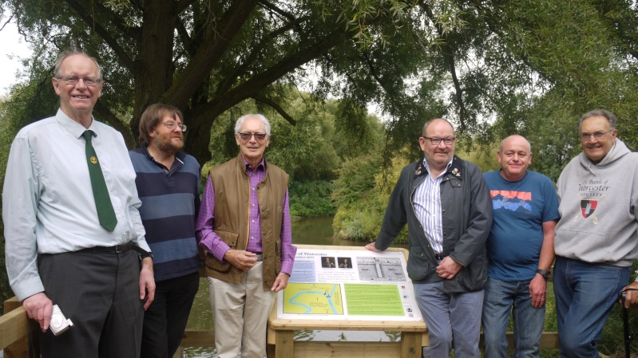

**From the left: Tony Spicer, BoWS and Battlefield Trust, Peter Gaunt, President of the Cromwell Association, Cecil Duckworth of the Duckworth Trust, Grant Simmonds, Chairman of the Battle of Worcester Heritage Partnership, James Burbeck, Duckworth Construction, Richard Shaw, Chairman, BoWS**

**CHRISTMAS TREE FESTIVAL 2018**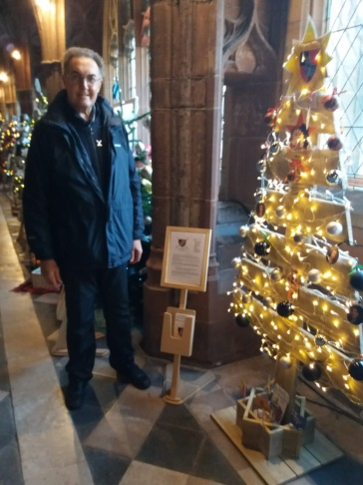

The Christmas Tree Festival is an amazing opportunity given to the City by the Cathedral to advertise local businesses and Societies. For a small donation we were able to place our tree in the Cathedral Cloister: literally thousands of people now know that we exist. Following an appeal to the Membership for help with the decoration of the Christmas Tree Festival, Society members Barbara Davies and Daniel Daniels volunteered to take on this project for us. We cannot thank them enough for taking the pressure off us at such a busy time of the year (for them as well as us). A HUGE thank you to you both!

**CHRISTMAS LUNCH AT THE WHITEHOUSE HOTEL on SUNDAY 9th DECEMBER 2018**

Thirty members attended the Christmas Lunch at the Whitehouse Hotel. The food was extremely good and the atmosphere was very jolly. We hope to do the same next year. If you haven’t been before, please consider joining us, it is a happy occasion.

**GRAND CHRISTMAS RAFFLE**

Our Chairman worked hard to get some decent prizes for the Grand Christmas Raffle which was held after the above Christmas Lunch.

The prize winners were as follows:-

|  |  |
| --- | --- |
| Tea and Tour of the House of Parliament | Tracey Manton |
| An Adams and Jefferson Maquette | Paul Langford |
| Afternoon tea at The Whitehouse Hotel | Sue and Roger Fairman |
| A GTECH hand held vacuum cleaner | Feriel Small |
| Four tickets to a Home County Championship cricket match | Jeannette Little |
| Two tickets to a Worcester Wolves home basketball game | Stella Langford |
| A bottle of red wine | Vaughan Wiltshire |
| Bottle of Gluhwein | Christine Shaw |
| Box of Belgian Chocolate Biscuits | Geoff Yapp |
| Bottle of vodka | Richard Jones |
| Bottle of Prosecco | Christopher Mayfield |
| A signed copy of *The Welsh Linnet* | Jenny Vale |

**CIVIL WAR NIGHTS’ SEASON 2019**

We have some very interesting speakers on some very interesting subjects lined up for 2019. I hope you can make the talks and please feel free to bring along friends and relatives.

**Thursday 23rd May**. Professor John Adamson, University of Buckingham and Fellow of Peterhouse, University of Cambridge. '*Venice on the Thames - What was the English Civil War Fought About?'*

**Thursday 20th June**. Dr Ismini Pells, University of Leicester

*'Civil War Petitions - Stories of Maimed Soldiers, War Widows and the Human Cost of War'*

**Thursday 18th July**. Professor Peter Gaunt, University of Chester and President of the Cromwell Association

*'The Nursery of the King's Infantry - Reassessing the Civil War in Wales 1642-46'*

**Thursday 15th August** Dr Victoria Anker, University of Birmingham

*'The City of Worcester - Civil War Destruction and the Process of Urban Repair'*

**Richard Graham, MP (Con) for Gloucester**

Christine and I attended the Gloucester History Festival last year where Richard Graham, who is also Chairman of the Gloucester History Trust, gave a very interesting talk on *Major General Edward Massey, a Parliamentarian at the siege of Gloucester in 1643 and a Royalist at the Battle of Worcester in 1651*. I invited him to give the talk during our Civil War Nights programme and he has accepted the invitation, saying that he would be delighted to attend. We will let you know as soon as we can what date that will take place.

**370 YEARS SINCE THE EXECUTION OF CHARLES I**

30th January 2019 will mark the 370th anniversary of the execution of King Charles I, the only time in British history that a Monarch has been executed. The eminent Historian David Starkey gave a talk at Huntingdon Hall in Worcester in 2015 to commemorate the 800th anniversary of Magna Carta. Mr Starkey started his talk by saying that Magna Carta was the second most important event in British history; the first was the execution of King Charles I in 1649.

We know that Charles I visited Worcester twice during the Civil War. The record *'Iter Carolinum'* sub titled "*being a succinct relation of the necessitated marches, retreats and sufferings of his majesty Charles I"*, (London 1660) places Charles at the Bishop's Palace in Deansway, Worcester for one night on 15 June 1644 having arrived from Bewdley and leaving the next day for Broadway.  He was also at Worcester from 31 August to 3 September 1645 (shortly after his crushing defeat at Naseby, Northamptonshire on 14th June 1645) having arrived from Morton and departed to Bromyard.  There is no indication of where he stayed for these three nights but it is most likely that he again stayed at the Bishop's Palace.  
   
Charles was a complex character, he had a stammer to his Scottish accent and at his coronation in 1626, at the age of 26, he was said to be only 4'8" tall. He lost the war and was put on trial at Westminster Hall in London charged with treason by declaring war on his own people. His trial lasted from 20th to 27th January 1649 and, not surprisingly he was found guilty and sentenced to death by beheading. So although the king was only a little chap, he was made considerable shorter on 30th January 1649!

**THE WASHINGTONS OF WORCESTER?**

The Royalist City of Worcester was besieged by a Parliamentarian army of 5,000 troops under the command of

General Edward Whalley and later Colonel Thomas Rainsborough from 21st May to 23rd July 1646. The Governor of Worcester was Colonel Henry Washington, who only had 104 defenders but having held the city for two months despite being bombarded by the huge cannon 'Roaring Meg' on Green Hill (which became Fort Royal in 1651) was obliged to surrender as they were very short of food and ammunition. From then until Charles Stuart arrived with his mainly Scottish army in August 1651, Worcester was a Parliamentarian city. The relationship between Henry Washington and George Washington, who became the first President of the USA in 1789 has been raised before but in the excellent 'On this day 100 years ago' column in the Worcester News of 14th November 2018 I noticed this item reproduced from 1918:-

*"On Wednesday, to the Birmingham Archaeological Society, Mr F. T. Spackman lectured on "The Washingtons of Worcester and the USA." The lecturer connected George Washington (the first President of the United States) with Worcestershire, because it was the ancestral home of the Washington family, and because there is in the village of Wickhamford the tomb of Penelope Washington* (who died in 1697)*, upon which are the words: "Sacred to the memory of Penelope Washington daughter of the distinguished and brave soldier Colonel Henry Washington." Mr Spackman showed how the coat of arms of the Washington family suggested the idea of the flag of the United States."*

When the Washingtons realised that the Royalist cause was well and truly lost they emigrated to Virginia, USA, still a British Colony in the 17th century, and George Washington was born there in 1732 from Henry's descendants.

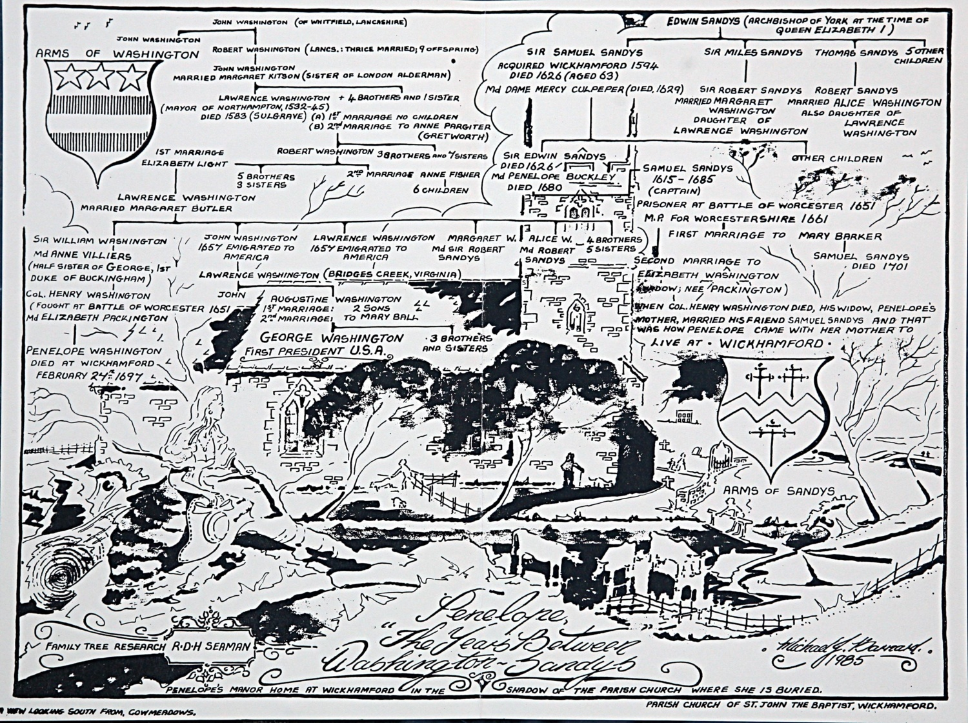

**ADAMS & JEFFERSON MONUMENT UPDATE**

We have reached £16,505.00. Thank you to everyone who has donated … so far.

**ANNUAL GENERAL MEETING**

**The Glass Room, The Hive, The Butts, Sawmill Walk, Worcester 7.00 p.m. for 7.30 p.m.**

To ensure synchronicity, the date of the AGM has been moved to Monday 25th February, 2019. Traditionally the Society has held the AGM in November. This will ensure that the whole of the financial year is represented in the accounts rather than November to November. The Charity Commission require accounts to cover 1 January to 31 December and this method will enable that.

We will be serving refreshments before and after the AGM including wine and soft drinks and substantial nibbles. The film *The Battle of Worcester* made by local man Joe Gaffneyand featuring the Worcester Re-enactors will be shown before the AGM.

We really do hope that you can join us and be instrumental in deciding who will be part of the Executive Committee next year and to vote for new Trustees also.

**-ooo000ooo-**

**DATES FOR YOUR DIARY**

**VISIT TO THE MEDIEVAL LIBRARY AT WORCESTER CATHEDRAL**

Monday 18th February 2019 at 2.30 p.m.

The cost of the visit is £6 per person.  Christine **will collect the money on the day.** Many of you will know the library already and that it is accessed by a very narrow and steep stone staircase.  However it is certainly worth the effort! The library and archive has been an integral part of the life of Worcester Cathedral since Anglo-Saxon times. The library enables ordinary people to see historic books and ancient documents. Doctor David Morrison, Librarian and Archivist will select documents and books for you to see relevant to the times of the English Civil Wars. Please email Christine on [seashells84@sky.com](mailto:seashells84@sky.com) if you would like to come on the tour.

**ANNUAL GENERAL MEETING**

**The Glass Room, The Hive, The Butts, Sawmill Walk, Worcester 7.00 p.m. for 7.30 p.m.**

**Monday 25th February, 2019**

**CREATIVE WRITING WORKSHOP**

**Saturday 13th April - 10.30 a.m. - 1.30 p.m.**

**The Commandery, Sidbury, Worcester**

**Cost: £20 per person.**

Local writer Sue Johnson is holding a Creative Writing Workshop and donating all of the proceeds to the **Battle of Worcester Society (Charity).**  Sue is published as a poet, short story writer and novelist and is a Writing Magazine Home Study Tutor.  (Further details of her work can be found at [www.writers-toolkit.co.uk](http://www.writers-toolkit.co.uk)). The workshop will be held in The Commandery, Sidbury, Worcester. Sue offers ideas to get you started and helpful advice and direction to improve your writing and get it out there! Suitable for beginners, those with a little more experience and established writers alike. The fee includes tea, coffee and home-made cake.

Please ring Christine on 01905 358640 or email her on [seashells84@sky.com](mailto:seashells84@sky.com) to book your place. Payment can be made in advance by cheque made out to T*he Battle of Worcester Society.*

**Please** book your place before the event.

**LIVING HISTORY IN WORCESTER SATURDAY 16th and SUNDAY 17th FEBRUARY 2019**

**The Commandery, Tudor House, Greyfriars, The Cathedral**

Join the Worcester Re-Enactors and re-enactors from all over the country where you will encounter characters throughout history to educate, inform and entertain.

**BOWS CHRISTMAS LUNCH 2019**

**Sunday 8th December, 2019 12.30 p.m. for 1.00 p.m.**

To be held at The Whitehouse Hotel, Foregate Street, Worcester

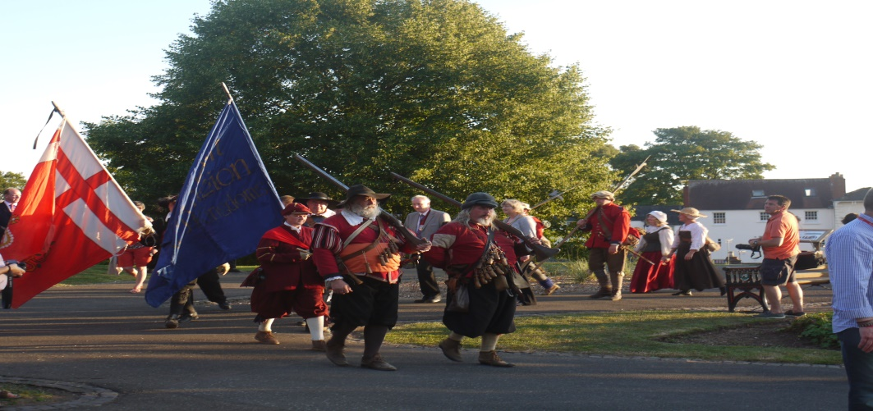

**PATRONS OF THE SOCIETY**

**His Grace The Duke of Hamilton ▪ Earl Spencer ▪ Lord Faulkner of Worcester**

**Lord Selkirk of Douglas ▪ Sir Robert Worcester ▪ The Hon. Lady Rosalind Morrison**

**Mr. Henry Berkeley ▪ Ms. Diane Rapaport**

**Professor Ron Hutton • Nigel Adams MP**

Executive Committee

**Richard Shaw (Chairman) ▪ Kenneth Potts**

**Vaughan Wiltshire**

**Christine Shaw (Treasurer and Membership Secretary)**

**Roger Fairman ▪ Brian Bullock ▪ Geoff Yapp• Guy Little • Robbie Porter**

**Trustees**

**Richard Shaw (Chairman) ▪ Vaughan Wiltshire (Honorary Secretary)**

**Jack Randall ▪ Peter Brookes ▪ Derek Law ▪ Christine Shaw**

**Roger Fairman ▪ Grant Simmonds ▪ Steve Hunt ▪ Ben Humphrey**

**Monument Appeal**

**Lord Richard Faulkner is Patron of the Appeal**

**Black Pear Bulletin Editorial Team**

**Christine Shaw**

**Richard Shaw**

**Tel. 01905 358640**

[**www.thebattleofworcestersociety.org.uk**](http://www.thebattleofworcestersociety.org.uk)