The Black

Pear Bulletin

*The Newsletter of the Battle of Worcester Society*

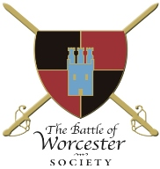Registered Charity Number: 1160010

**Issue No. 23 ~ Spring 2019**

**OUR CHAIRMAN WRITES**

Welcome to the Spring edition of the Society’s newsletter and a particular welcome to all our new members. The spring and summer of 2019 contains many events of interest, all of which you will find itemised at the bottom of the newsletter under ‘Dates for your diary’. If you can be of any help at any of the events we would welcome your support, just let us know when you can come. So far, we have held four events, all of which are detailed below. They were very successful so we look forward to bringing you more enjoyment in the months to come.

**ANNUAL GENERAL MEETING at The Hive**

To ensure synchronicity, the date of the AGM was moved to Monday 25th February, 2019. Traditionally the Society has held the AGM in November. This ensured that the whole of the financial year is represented in the accounts rather than November to November. The Charity Commission requires accounts to cover 1 January to 31 December and this method will enable that.

Thirty people attended the AGM which is approximately one third of the Society’s membership. We are grateful that such a large percentage came. Trustees in the year have been Richard Shaw (Chairman) Christine Shaw (Membership Secretary and Hon. Treasurer) Vaughan Wiltshire (Hon Secretary) Peter Brookes, Roger Fairman, Ben Humphrey, Derek Law, Jack Randall, Jabbar Riaz (Mayor of Worcester), Steve Hunt and Grant Simmonds MBE. In the year we have had resignations as trustees from Jabbar Riaz, Derek Law and Steve Hunt who remain members of the Society. Under the Constitution 3 Trustees stood down this year and were eligible for re-election: they were Richard Shaw, Christine Shaw, and Vaughan Wiltshire. All confirmed their willingness to stand again as Trustees.

We now have three new Trustees Daniel Daniels, Geoff Yapp and Guy Little who will assume the roles of Vice Chairman, Hon Treasurer and Hon Secretary of the Charity (they will now also be members of the Executive Committee). Christine Shaw has kindly agreed to continue as Membership Secretary and Hon. Secretary of the Executive Committee. Christine also produces and distributes the Black Pear Journal. I thank them all for their contributions and attendance at the Board over the last year.

Before the AGM proper we had the opportunity to enjoy again the film *The Battle of Worcester* made by local man Joe Gaffneyand featuring the Worcester Re-enactors. It got the AGM off to a good start. Drinks and canapés were enjoyed after the meeting.

**VISIT TO THE MEDIEVAL LIBRARY AT WORCESTER CATHEDRAL**

On Monday 18th February 2019 this outing was attended by twenty members of the Society who enjoyed the visit tremendously. Doctor David Morrison, Librarian and Archivist had selected documents and books for the party to see which were relevant to the times of the English Civil Wars, together with some of the library’s older documents which dated from the 8th century.

This event was oversubscribed, so if there are members who would like to visit the Library, Christine is happy to organise another visit. Please let her know by email if you are interested and she can go from there.

**CREATIVE WRITING WORKSHOP**

**Saturday 13th April - 10.30 a.m. - 1.30 p.m. held at The Commandery, Sidbury, Worcester**

Local writer Sue Johnson held a Creative Writing Workshop and donated all of the proceeds to theBattle of Worcester Society**.**  Sue is published as a poet, short story writer and novelist and is a Writing Magazine Home Study Tutor.  Ten scribes attended at £20 each + 10% of money taken from the sale of Sue’s books (amounting to £203 for the Society) and they all had a simply lovely time. The fee included tea, coffee and lashes of home-made cake. Thank you so much to Sue for donating her time and expertise, thank you to the Commandery for donating the room and thank you to Christine who donated all cakes and refreshment.

**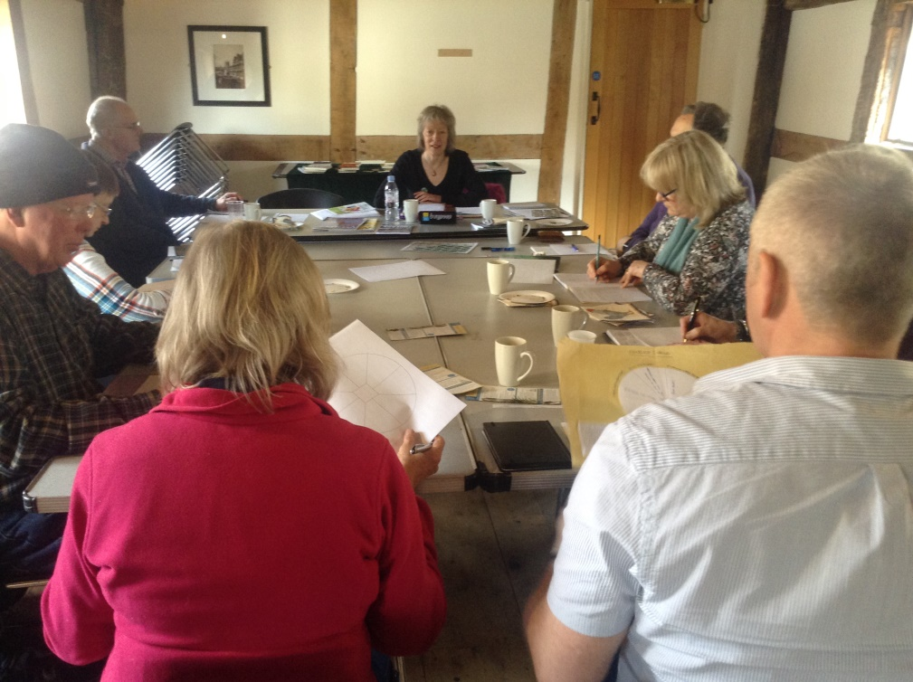**

**CIVIL WAR NIGHTS - Thursday 2nd May, 2019**

**Richard Graham, MP (Con) for Gloucester**

*Major General Edward Massey, Hero, Traitor or Survivor?*

We were delighted to welcome Richard Graham to The Commandery who won over the audience with his considerable charm. He gave a very interesting talk on Major General Edward Massey MP, who was the Parliamentary Governor of Gloucester when the city was besieged by King Charles I and his Royalist Army in 1643.  Yet Massey was in the Royalist army of King Charles II at the battle of Worcester in 1651 and was wounded in the skirmish at Upton-upon-Severn.

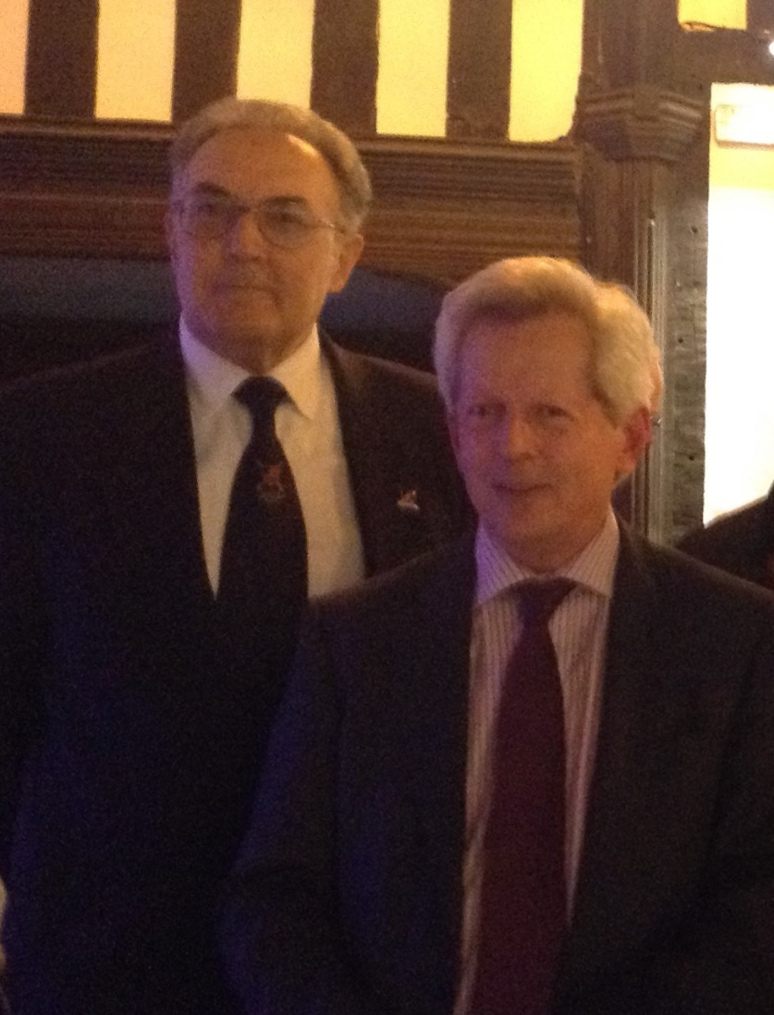

Over forty paying guests came to listen to

Richard Graham's talk. He is accompanied here by Richard Shaw – Chairman of the Battle of Worcester Society

**WORCESTER LOTTERY**

The Worcester Lottery started on 27th March 2019 and already the Battle of Worcester Society has received £52.50 in proceeds from our 11 supporters. The more supporters we have the more we will receive. If you haven't already enrolled please give it a go. For just a £1 entry you could win £27,000. **50p** of your £1 goes into **our** bank account.

If you log on to [*www.worcesterlottery.org*](http://www.worcesterlottery.org) you will see a green box with 'Support a Specific Cause' thereon. Type "battle" and our society name comes up, click on that, then "buy tickets."

Enter your six numbers or "chose for me" and you are in business. You may also enter by telephone on 01905 556789. It is a weekly draw. Best of luck and thank you to all who have supported the Society so far.

**YATE FLAGS**

St Mary the Virgin Church at Bromsberrow Heath is the home to two English Civil War banners: they are held in the Yate Chapel. The banners date back to 1643 – the second year of the English Civil War and two years before the skirmish at Ledbury. Both flags are believed to have been carried by a Royalist officer, one revealing his loyalty and the other, as a trophy of war. The banners have been the property of the church for hundreds of years and are installed in a specially made cabinet. The banners have been declared by Dr Holmes, an Emeritus Fellow of Lady Margaret Hall, Oxford as being “quite extraordinary; one is Royalist and the other Parliamentarian … these were owned by Colonel Rice Yate, a young Royalist officer who captured the red Parliamentarian standard and kept it alongside his own white Royalist banner: … they are the finest examples in the whole of England.”

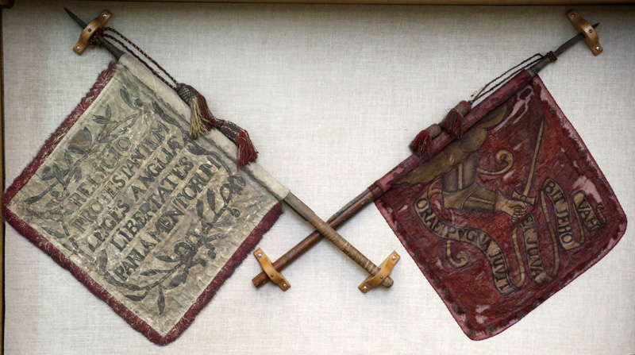

In February 2017, the Worcester Embroiderers’ Guild was approached by Kerry, a member of staff at the Commandery, to see if anyone in the branch could help to reproduce these two standards as exhibits for the museum.

The banners were in a fragile state and some conservation work had already been carried out on them by the Royal School of Needlework. The Royalist standard is of white silk and bears the words “*Religio Protestantium, Leges Angliae, Libertates Parliamentorum*”. The Parliament standard is of red flowered silk, with a painting showing an arm in armour, thrust from a cloud and a hand holding a sword. On the flag are the words “*Ora et Pugna*” and “*Juvit et Juvabit Jehovah*”.

Following a visit to St. Mary’s, a small number of members agreed to take part in the project. However, it was realised that the work would not really involve embroidery as such, but other skills such as dyeing and stencilling. Experimentation to ensure that the new flags were as close to the originals as possible meant that the project took much longer than anticipated; it was finally completed in August 2018.

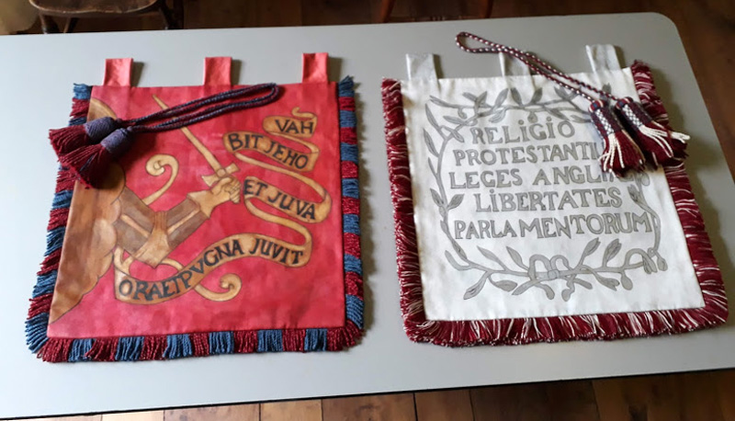

To see the process of replicating these flags it is worth visiting the Embroiderers’ Guild website <http://www.worcesterembroiderersguild.org.uk/>

On 24th November 2018 former Church Wardens, Nick Winter and Jan Long brought the original standards to The Commandery and Jan Long gave a full and interesting talk about the Church, the standards and their history. The replicas have now been placed in *Worcester’s Civil War Story* and are a great addition to the exhibition.

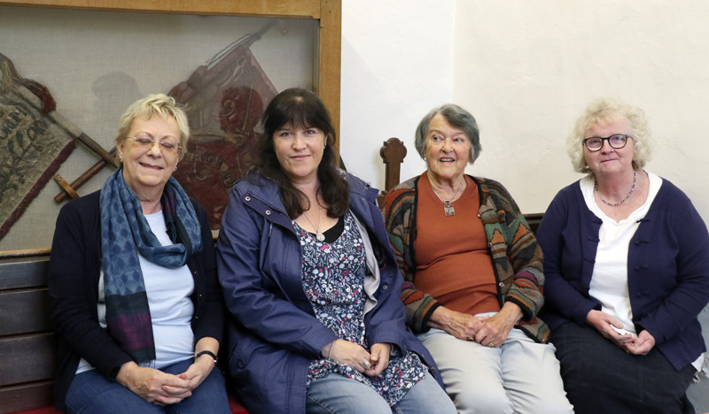

Kerry (second left) from The Commandery and the Craftswomen

**MEMBERSHIP AT THE COMMANDERY**

Helen Large who is the Manager – Audiences, Communications & Development for Museums Worcestershire has asked for details of Membership at The Commandery to be included in this newsletter.

By becoming a member of The Commandery Worcester one can enjoy a range of exclusive benefits including special member-only events and shop discounts. Membership includes an annual visitor’s pass along with a whole host of other fantastic member only benefits. Members will be informed in the ongoing development of The Commandery and the Membership fee and donations allow investments in new and exciting collections and events. This year they have been able to purchase a rare gilt silver pendent, worn in the 17th century as a way to show loyalty to King Charles I. All Membership fees and donations go back into The Commandery to support their work. Memberships can be individual or as a family and there are also options to become a joint member of both The Commandery and the Worcester City Art Gallery & Museum.

The Battle of Worcester Society supports the Membership Scheme by sponsoring Members Row at their programme of Civil War Nights 2019 talks at The Commandery. If you would like access to these unique benefits please contact [Helen.Large@worcester.gov.uk](mailto:Helen.Large@worcester.gov.uk) call 01905 361821 or visit [www.museumsworcestershire.org.uk](http://www.museumsworcestershire.org.uk)

**BATTLE OF WORCESTER VIEWPOINT**

The long awaited dualisation of the ‘new’ Worcester Bridge over the river Severn is in the process of taking place. As part of the developers’ preparation for this mammoth task, they have removed the Battle of Worcester viewpoint. After deforestation, came destruction and then desolation. The Society has been told that they will be part of the consultation process once the City Council is in a position to replace the viewpoint. I suspect that this will take one or two years at least to put in place.

**[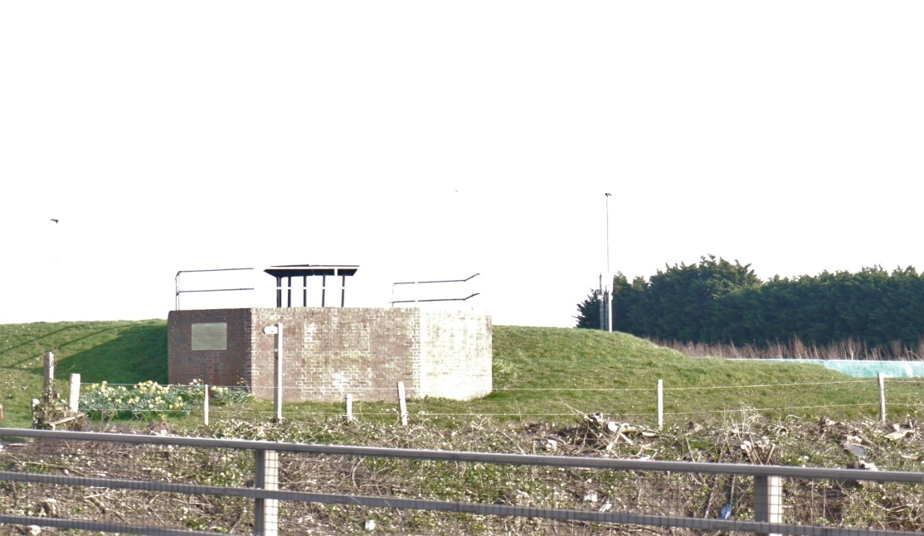](http://moneyadviceandhelp.com/new/?bank=1&utm=tbl100&utm_source=taboola&utm_medium=referral" \o "Lloyds Is Issuing Large Refunds To Customers - Look Up Your Name" \t "_blank)**

**After deforestation**

**DATES FOR YOUR DIARY**

**CIVIL WAR NIGHTS SEASON –**

**all talks are being held in the Great Hall at The Commandery.**

**They start at 7.00 p.m. – doors open at 6.00 p.m. – Commandery Café is open until 7.00 p.m. serving refreshments**

**Tickets: £5 members, £7 guests, £3 students – available from The Commandery Shop, the Tourist Information Centre, at the door on the night or from our newly updated website:** <https://www.thebattleofworcestersociety.org.uk/>

**Thursday 20th June, 2019 - Dr Ismini Pells, University of Leicester**

*'Civil War Petitions - Stories of Maimed Soldiers, War Widows and the Human Cost of War'*

[https://www.civilwarpetitions.ac.uk/](https://wwwcivilwarpetitions.ac.uk/)

**Thursday 18th July, 2019 - Professor Peter Gaunt, University of Chester and President of the Cromwell Association**

*'The Nursery of the King's Infantry - Reassessing the Civil War in Wales 1642-46'*

**Thursday 15th August, 2019 - Dr Victoria Anker, University of Birmingham**

*'The City of Worcester - Civil War Destruction and the Process of Urban Repair'*

**Thursday 19th September, 2019 - Sharon Himes from Worcester County, Maryland, USA**

*'The story of Henry Norwood a Royalist Dragoon under Henry Washington during the 1646 siege of Worcester'*

**DRUMHEAD SERVICE - Tuesday 3rd September 2019**

This will start with a parade from the Guildhall at 5.00 p.m. with the full Mayoral Party and Re-enactors. All members of the Society are invited together with the general public. We will parade to The Commandery (no charge for entry) where the Cardinal's Hat has agreed to set up a 17th century bar. Then at 6:45 p.m. we will parade up to Fort Royal Park where Canon Michael Brierley will conduct a service in remembrance of the 3,200 men who were killed during the Battle of Worcester. This will be followed by one minute's silence. All welcome.

**M5 AT SPETCHLEY**

<http://www.worcesterreenactors.uk/m5/m5-information-for-visitors/>

**Saturday 10th and Sunday 11th August, 2019**

The Society is attending this event with a gazebo and hopes to sell merchandise and spread the word on the Promotion, Protection and Preservation of Worcester’s World Heritage. If anyone would like to help us in these efforts, even if you can only do a morning or an afternoon, we would be most grateful. Richard and Christine Shaw are able to look after the stall on Saturday 10th and would welcome company, but are otherwise engaged on Sunday 11th – please see below. There is a cost to entering this show, but if you are officially helping us on the stall the entrance is free. Please get in touch.

**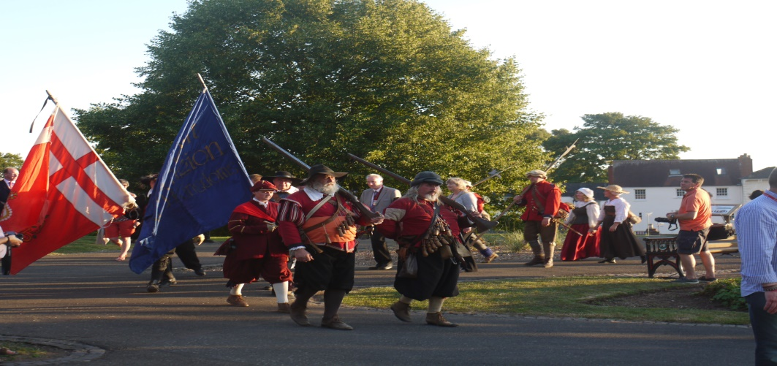**

**WORCESTER SHOW**

<https://www.worcestershow.org.uk/>

**Sunday 11th August, 2019 in Gheluvelt Park**

The Society is attending the Worcester Show for the first time in its history. We have hired a stall and we intend to share our ethos of Protecting, Preserving and Promoting conservation and development of Worcester’s World heritage. We also hope to advance the education of the public in the history of the Battle of Worcester and other events related to the English Civil Wars. Again, it would help if one or two members could cover for an hour or so. This is a free event.

**MONARCH’S WAY WALK**

<https://www.walkingbritain.co.uk/walk-1830-description>

**Ombersley Walking Group - 10am Saturday 1st June**

The trail takes in a small section of the Monarch's Way, a 625-mile long-distance footpath in England that traces the escape route taken by King Charles II in 1651 after being defeated at the Battle of Worcester. The five-mile circular route is pretty flat with quite a few footpaths. Stiles will be kept to a minimum, no more than half-a-dozen.

After the walk, which will finish around mid-day; hot refreshments will be provided in the hall. Walkers are invited to make a small donation of £1 per head towards the cost of refreshments. The surplus will be given to the hall committee as a contribution towards overheads.

Children are welcome. Dogs are welcome too but under close control and on a short lead. Everyone is responsible for their own safety. There is no need to register for the walk. Just turn up on the day. Start and finish at Ombersley Memorial Hall where parking is available. If you feel you need more information the Parish Paths Warden is Peter Reynolds on 07855 441804.

**SELF-DRIVE BATTLEFIELD TOUR OF WORCESTER 1651**

**Saturday 7th September, 2019 11.00 a.m. Toby Carvery West, (The Ketch) Bath Road, Worcester WR5 3HW**

A joint Battlefields Trust/ Battle of Worcester Society self-drive Battlefield tour of Worcester 1651 led by Guild of Battlefield Guides accredited guide Anthony Rich.   Contact [anthonyrich@virginmedia.com](mailto:anthonyrich@virginmedia.com) Tel 07711-086189 to book a place, to arrange car shares or for questions. No charge for Battlefields Trust or Battle of Worcester Society Members. Non-members invited to make a charitable donation to the Trust & Society’s work. Refreshments and entry to Commandery (optional) payable direct. Participation at organisers’ discretion. Organisers reserve right to cancel or amend tour without notice.

**BOWS CHRISTMAS LUNCH 2019**

**Sunday 8th December, 2019 12.30 p.m. for 1.00 p.m.**

To be held at The Whitehouse Hotel, Foregate Street, Worcester. Details nearer the time.

**PATRONS OF THE SOCIETY**

**His Grace The Duke of Hamilton ▪ Earl Spencer ▪ Lord Faulkner of Worcester**

**Lord Selkirk of Douglas ▪ Sir Robert Worcester ▪ The Hon. Lady Rosalind Morrison**

**Mr. Henry Berkeley ▪ Ms. Diane Rapaport**

**Professor Ron Hutton • Nigel Adams MP**

**Executive Committee**

**Richard Shaw (Chairman) ▪ Daniel Daniels (Vice Chairman)**

**Geoff Yapp (Hon. Treasurer) ▪ Christine Shaw (Honorary and Membership Secretary)**

**Guy Little (Hon Secretary of the Trustees) ▪ Vaughan Wiltshire**

**Kenneth Potts ▪ Roger Fairman ▪ Brian Bullock ▪ Robbie Porter ▪ Tim Young**

**Trustees**

**Richard Shaw (Chairman) ▪ Guy Little (Hon. Secretary)**

**Jack Randall ▪ Peter Brookes ▪ Christine Shaw ▪ Roger Fairman ▪ Grant Simmonds**

**Ben Humphrey ▪ Geoff Yapp ▪ Daniel Daniels ▪ Vaughan Wiltshire**

**Monument Appeal**

**Lord Richard Faulkner is Patron of the Appeal**

**Black Pear Bulletin Editorial Team**

**Christine Shaw**

**Richard Shaw**

**Tel. 01905 358640**

[**www.thebattleofworcestersociety.org.uk**](http://www.thebattleofworcestersociety.org.uk)