The Black

Pear Bulletin

*The Newsletter of the Battle of Worcester Society*

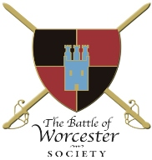Registered Charity Number: 1160010

**Issue No. 24 ~ Autumn 2019**

**OUR CHAIRMAN WRITES**

I am sorry that I have not been around quite as often as I would like to have been. I was admitted to Worcestershire Royal Hospital on 24th August with sepsis and pulmonary embolisms and was devasted to have missed the announcement of the finding of the Battle of Worcester Artefacts (although I was aware of them) and equally importantly missing the Drumhead Parade and Commemorative Service. I have been in hospital for five weeks and am slowly regaining fitness and health. I look forward to getting back into the thick of things including our new initiative, History Talks (non-civil war) which we are holding monthly during the Winter at The Hive. We hope to attract a different audience who will become interested in the Battle of Worcester Society and its ethos.

**M5 AT SPETCHLEY**

**Saturday 10th and Sunday 11th August, 2019**

The Society did not attend this event in the end as the Chairman came out of hospital on 9th August and was not fit enough to battle with putting up a gazebo in the forecast winds and rain. I understand that the weather did become calmer during the day and that the event was a great success. Congratulations to the Worcester Re-enactors who organised the whole shebang.

**WORCESTER SHOW**

**Sunday 11th August, 2019 in Gheluvelt Park**

However, the Society did attend the Worcester Show for the first time in its history. Thanks to fairly new Executive Committee Member Tim Young and his wife Karen, the stall was very looked after for the whole day. We met many interesting people and many who were interested in both the Battle of Worcester Society and the Battle itself.

**BLACK PEAR JOGGERS – BATTLE RUN**

**Monday 2nd September, 2019**

Member Duncan Sutcliffe of the Black Pear Joggers reports that the Black Pear Joggers had 30 runners and one dog join them on their annual run taking in some of the historic sites and learning about the battle. Running though Perry Wood at dusk on 2nd September where Cromwell met the Devil was suitably creepy!

Black Pear Joggers outside King Charles House

Black Pear Joggers at Elbury Mount on 2 September, 2019

**Archaeologists find evidence of the Battle of Worcester at construction site**

News released 3rd September, 2019 - Words taken from the Worcester News

**ARTEFACTS have been discovered from the Battle of Worcester which is the first time archaeologists have been able to pinpoint where the battle took place.**

Musket balls, horse harness fittings, horseshoes and belt buckles are among the artefacts that have been found at a construction site in Powick. Historians have always known the area was the site of the final battle of the Civil War, but no actual physical evidence had ever been found and recovered until this find. Richard Bradley, onsite lead archaeologist said: “It is fantastic to be able to finally locate and map physical remains of the battle and to relate this to the historical record. “We are just outside the registered battlefield area, but this is still a nationally significant site.” Mr Bradley added: “The construction work has given us the opportunity to investigate the floodplain across which thousands of infantry and cavalry engaged, and to get down to the level where artefacts were deposited.

“Many of the lead musket and pistol balls show evidence of firing or impact and these tangible signs of the conflict offer a poignant connection to the soldiers who fought and died here.”  There’s shot damage on the nearby church tower at Powick and Powick Bridge was reportedly the location of intense fighting. Archaeologists examined the land using specialist methods, where they soon began to find evidence of the battle. The artefacts were buried deep at the bottom of a river valley, covered by flood deposits accumulated over hundreds of years since the battle.

Derek Hurst, project archaeological consultant said: “For the first time we have been able to pinpoint the buried Civil War horizon within the flood silts built up across the flood plain – and the key to this has been special scientific investigation of the flood silts using optically stimulated luminescence. “The results from this have enabled us to focus our efforts quite precisely which has meant much tine saving and so saving on costs, as well as getting a brilliant archaeological outcome.”

The artefacts from the battle of 1651 have been discovered at the site, which is part of an infrastructure project being delivered by [**Worcestershire County Council**](https://www.worcesternews.co.uk/search/?search=Worcestershire+County+Council&topic_id=4578) to dual between [**M5**](https://www.worcesternews.co.uk/search/?search=M5+motorway&topic_id=7469) and Powick roundabout. Part of the scheme involves the building of a flood compensation area and, as part of the programme works, archaeologists from the council were given the opportunity to explore the land for any potential find. The objects found will now be analysed and recorded.

Richard Shaw, chairman of the Battle of Worcester Society said: “How exciting that 368 years after the Battle of Worcester these artefacts should be discovered. “Parliamentary forces had crossed the river at Upton-upon-Severn and were driving the Royalists back to Worcester, the discoveries really bring the events of that day to life.”

Councillor Lucy Hodgson, cabinet member with responsibility for communities added: “Finding these fascinating artefacts allows us to connect with a significant moment in Worcestershire’s history. “Preserving our history is vitally important to our county and this latest dig is a shining example of how archaeology can bring our past to life.”

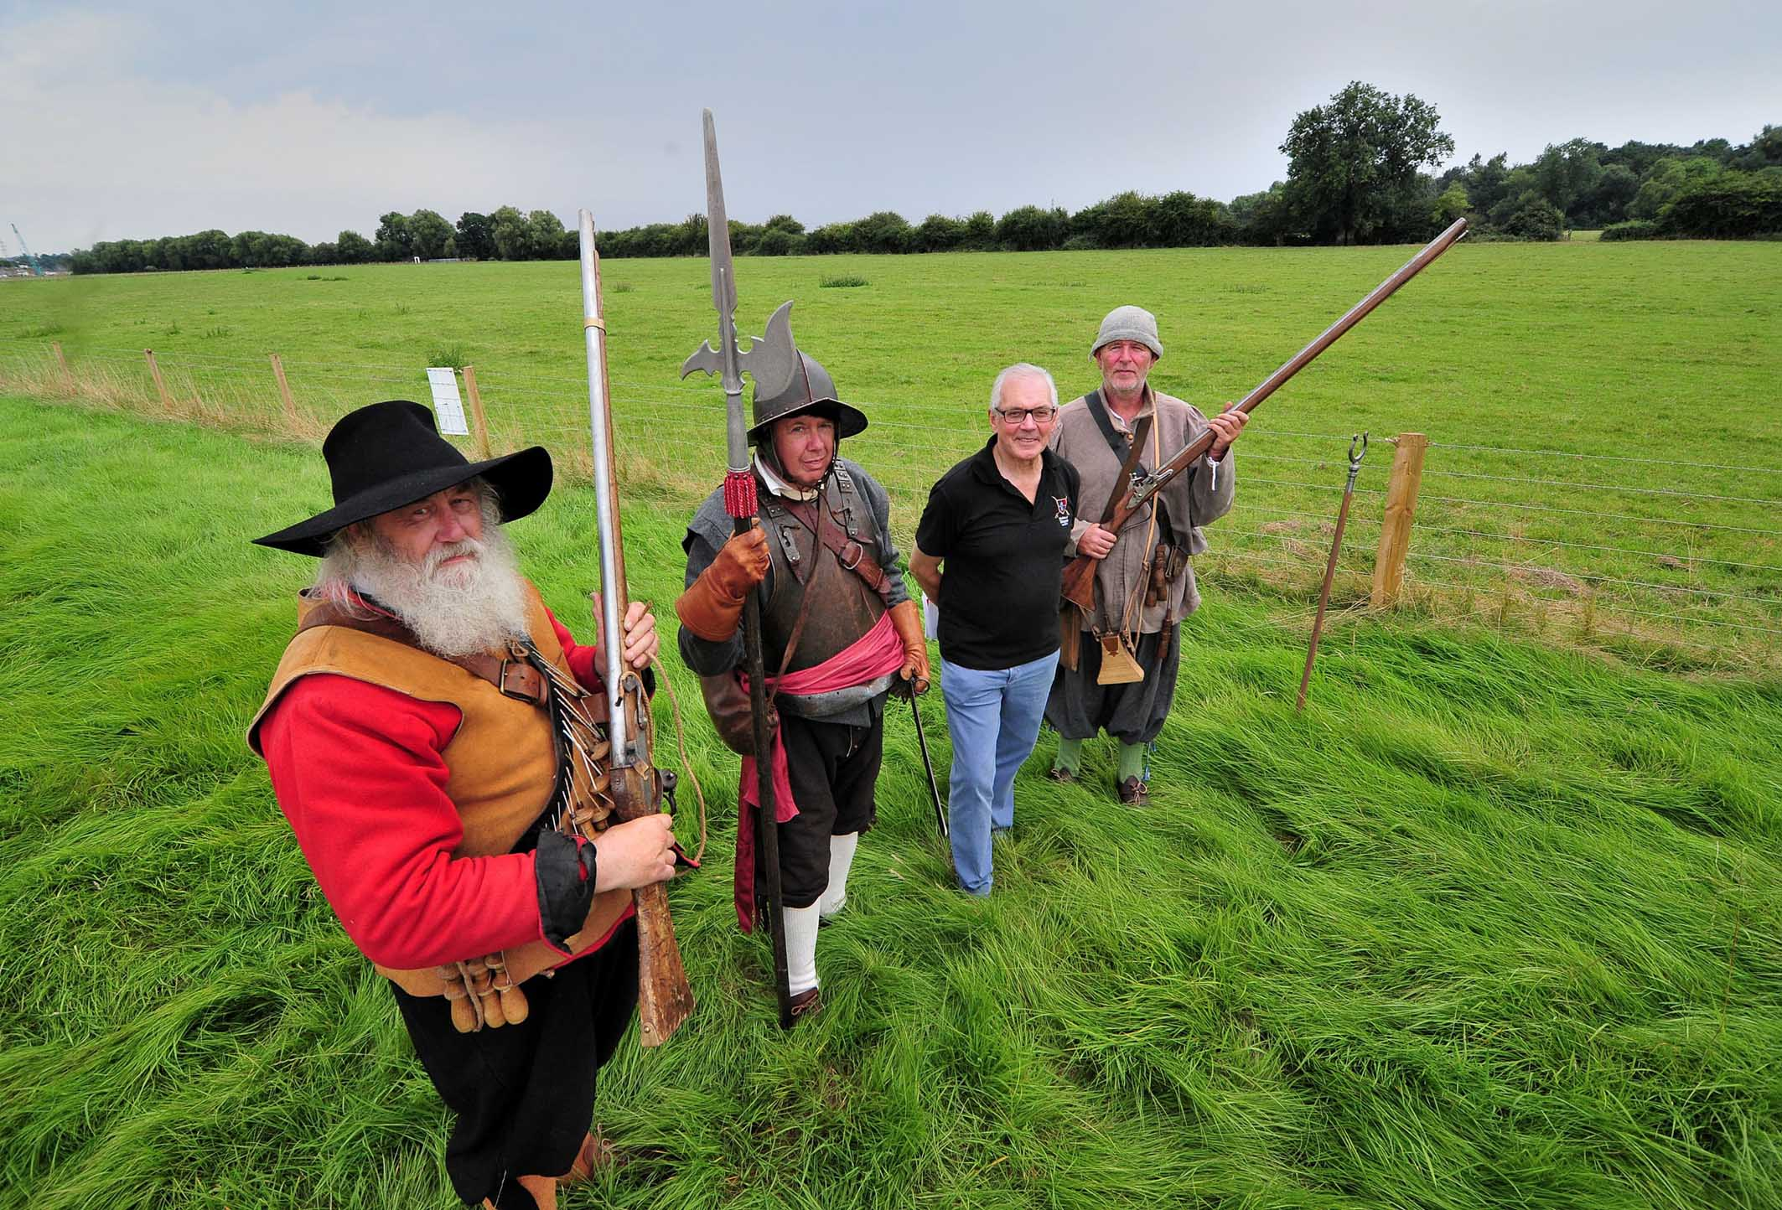

Re-enactors and BOWS members Brian Bullock and Roger Fairman. Vaughan Wiltshire Executive Committee member of BOWS and re-enactor Andy Tivenan

**Jonathan Barry, Photographer**

**DRUMHEAD SERVICE - Tuesday 3rd September 2019**

The Drumhead parade started from the Guildhall at 5.00 p.m. with the full Mayoral Party and Re-enactors. All members of the Society were invited together with the general public. The Re-enactors led the parade to The Commandery where the Cardinal's Hat had agreed to set up a 17th century bar. At 6:45 p.m. the group paraded up Fort Royal Hill where Vice Chairman Daniel Daniels led the proceedings. The Reverend Rob Farmer conducted a service in remembrance of the 3,200 men who were killed during the Battle of Worcester and those who also died as a result of the battle. The service included one minute’s silence, the beginning of end of which was marked by the Worcester Re-enactors firing their muskets.

For the first time we were privileged to have a police escort from the Guildhall to the Commandery and later from the Commandery to Fort Royal Hill. Thank you to Sgt Paul Smith who arranged cover.

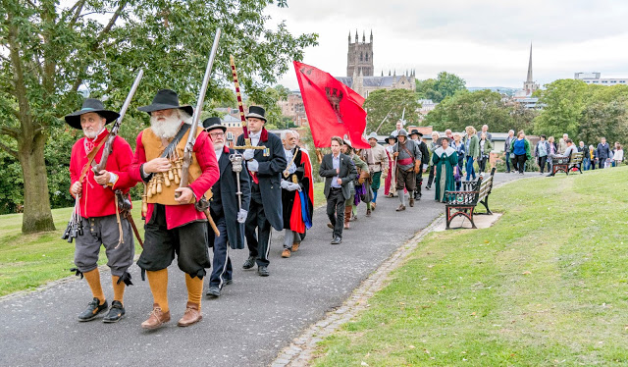

This photograph - and the whole event - was captured by Ferez Fee who has posted all his beautiful photographs taken on the day at the following link:

<https://www.facebook.com/ferez.fee>

**SELF-DRIVE BATTLEFIELD TOUR OF WORCESTER 1651**

**Saturday 7th September, 2019 11.00 a.m. Bath Road, Worcester**

A joint Battlefields Trust/ Battle of Worcester Society self-drive Battlefield tour of Worcester 1651 led by Guild of Battlefield Guides accredited guide Anthony Rich took place on 7th September. The tour included a walk along the river to the new Bridge of Boats Information Board.   Anthony reports that the tour went well.

**CIVIL WAR NIGHTS**

Our last two talks were presented by two female authors from opposite sides of the Atlantic Ocean but with much in common. Elaine Joyce, who has many family connections to Worcester, talked to us about Colonel William Carless, *The Hero of the Boscobel Oak Tree*who originated from Bishampton near Pershore and was a devout Royalist.  He fought in many English Civil War battles (1642-1651) including the final and decisive battle at Worcester on 3rd September 1651 when the Royalist army was routed by the Parliamentarians.  When Carless was sure Charles Stuart had escaped, he made his own escape and caught up with Charles the day after the battle at Boscobel House.  The two of them hid up an oak tree while Parliamentarian soldiers searched the wood below them. Both survived and when King Charles returned to be restored to the throne in 1660, Carless came to live at Hallow, Worcester and his wife is buried there. This was Elaine’s first presentation in support of her book *'Nine Witnesses for the Colonel - King Charles’ Most Faithfull Servant'* and it was a most excellent evening.

Elaine Joyce with four likely looking lads!  L to R Brian Bullock, Richard Shaw (Chairman) Daniel Daniels (VC) and Tim Young





Elaine Joyce with four likely looking lads!

From L to R, Brian Bullock, Richard Shaw (BOWS Chairman), Daniel Daniels (BOWS VC) and

Tim Young BOWS Executive Committee Member

**On September 19th 2019, we welcomed Sharon Himes** of Worcester County, Maryland, USA to the Commandery where she told the totally fascinating story of Colonel Henry Norwood in her talk entitled *Col. Henry Norwood – A Cavalier’s Odyssey in the service of the King.* It is extraordinary that her interest in her own local history led her all the way to Worcester, England. Henry Norwood was a Colonel in Henry Washington’s dragoons and he fought in several Civil War battles. He survived the siege of Worcester to later take a trip to Virginia for the King. He was shipwrecked and his story of survival among the Native Americans was a large part of Sharon’s talk. Once home his adventures continued and Sharon is extending her original book *A Cavalier’s Adventures* to include them. Colonel Norwood eventually retired to Leckhampton Court in Gloucestershire and died there in 1689.

This was another truly fascinating evening. The Society is most grateful to both Elaine and Sharon for entertaining us in such a grand manner and to hear true narratives with a direct connection to Worcester and the Battle.

**VISIT TO MOSELEY OLD HALL**

**11 September, 2019**

A small coach load of 36 members of the Society and other supporters had a wonderful day at Mosely Old Hall in Featherstone, Staffordshire. Moseley Old Hall is a National Trust property and has an amazing history connected to Charles Stuart and his escape from the Battle of Worcester in 1651.  We heard the story of how he sought shelter in the Hall and how he hid in the priest’s hole. The bed that was provided for his use is still there and the National Trust has the provenance to prove it.  The door described by Samuel Pepys as told to him by the King is still in the Hall. The weather was glorious, the guides were knowledgeable, the scones were delicious, the company was great and to top it all, pears were growing on the Worcester Black Pear tree! Thanks to all who supported this event.

**HISTORY TALKS – (NON CIVIL WAR SUBJECTS) – A NEW INITIATIVE**

The Society has decided to hold a winter season of history talks, but this time we will not feature Civil War subjects. The talks will be held in The Studio at The Hive and will be held on a Wednesday in October, November, January, February and March. It was thought that perhaps we could attract an audience from the other side of town, who may wish to be part of our Society once they know what we are about. The subjects of the talks are varied and a full programme is listed below. We would be most grateful for your support for this new idea, and we hope that you will enjoy them too. The talks start at 7.15 p.m. and run until 8.00 p.m. (ish) followed by a Q and A session. The Hive café is open until 9.00 p.m. and the car park is large. The fee for parking your car after 7.00 p.m. is just £1.

Please don’t think that we are abandoning our normal Civil War Nights’ Spring/Summer season at The Commandery. It will occur as usual with our first talk in April: the programme is already beginning to take shape.

The programme for the History talks is as follows:

**BOWS WINTER TALKS 2019 / 2020**

**The Studio, The Hive, Sawmill Walk, Worcester - All talks begin at 7.15 p.m.**

**9 October, 2019** –

Tim Heath: **Hitler’s Girls**

Tim’s talk will focus on the content of his first two books – *Hitler’s Girls – Doves amongst Eagles* (which covers the indoctrination of German female youth and entry into the two female Hitler Youth organisations) and *In Hitler’s Shadow – Post-war Germany and the girls of the BDM* which reveals more wartime tales and how many of the girls fared in the wake of World War II.

Books published so far:

1. Hitler's Girls-Doves Amongst Eagles. This book covers the indoctrination of German female youth and entry into the two female Hitler Youth organizations.

2. In Hitler's Shadow-Post war Germany and the girls of the BDM. This book reveals a few more wartime tales and how many of the girls fared in the wake of WW2.

3. Creating Hitler's Germany-the birth of extremism. Germany's descent into chaos, pre-WW1, the rise of Hitler and the Third Reich and WW2 told through the eyes of families who witnessed these traumatic times.

**Bio:** - Born into a military family, Tim Heath's interest in history led him to research the air war of the Second World War, focussing on the German Luftwaffe and writing extensively for The Armourer Magazine. During the course of his research he has worked closely with the German War Graves Commission at Kassel, Germany, and met with German families and veterans alike. Born out of this work, Hitler's Girls is his first book. He lives in Evesham, Worcestershire, with his partner Paula.

**13 November 2019** –

Geoff Yapp: **The Siege of Louisbourg 1758 - Prelude to Gen Wolf's Victory at Quebec**

Our second talk will  move across the Atlantic, where Geoff will cover the interesting Anglo-American campaign to capture the French fortified city of Louisbourg in what is now Nova Scotia.  He will discuss how the joint navy/army campaign closed the St Lawrence to French shipping and effectively decided the fate of French Canada before the British even arrived at Quebec.

**Bio** – Towards the end of his career in the Royal Air Force, Geoff was the Defence Attaché in Canada, so has met many very strong opinions from both the Anglo and Québécois communities. He subsequently taught, among other things, military history at the Baltic Defence College in Estonia before retiring to Worcester where he now supports the Battle of Worcester Society.

**15 January, 2020** –

Guy Little: **Pirates, Slavers, Old Adversaries and Emerging International Rivals.**

The limitations of Mid-Victorian naval coercion explored circa 1846-1871

**Bio** – Guy is an amateur historian with a keen interest in the role of the Royal Navy generally. This led to completion of a Master’s Degree in Naval History through the University of Portsmouth in 2019 where the 19th century was of particular interest to him.

**19 February, 2020** –

Robbie Porter: **The Worcestershire Regiment at Gallipoli**

**Bio** - 'Robbie Porter is a lecturer and charity worker originally from Hawick, Scotland. He studied History at Sunderland and has lived in Worcester since 1991. He became interested in Gallipoli after discovering that his grandfather took part in the attacks at Achi Baba Nullah on 12 July 1915. This present talk will examine the military and political background to the campaign, the 4th Worcestershire's difficult landing at Cape Helles as well as critical engagements including the First and Third Battles of Krithia.'

**18 March, 2020 –**

Steve Dunn: another local author who has published at least four history books and another is due out at the end of January 2020.  His books include *The Coward?* and *The Scapegoat.*

**Bio** – Steve R Dunn is an author who has a special interest in the British Navy of the early 20th century and WW1. He has seven published works to his credit with another two commissioned for 2020 and 2021.

Thank you so much to Duncan Sutcliffe for the generous sponsorship of these events.

***********************************************************************************************

**BOWS CHRISTMAS LUNCH 2019**

**Sunday 8th December, 2019 12.30 p.m. for 1.00 p.m. at the Whitehouse Hotel, Foregate Street, Worcester**

No details as yet, but they will be emailed to you as soon as we receive them.

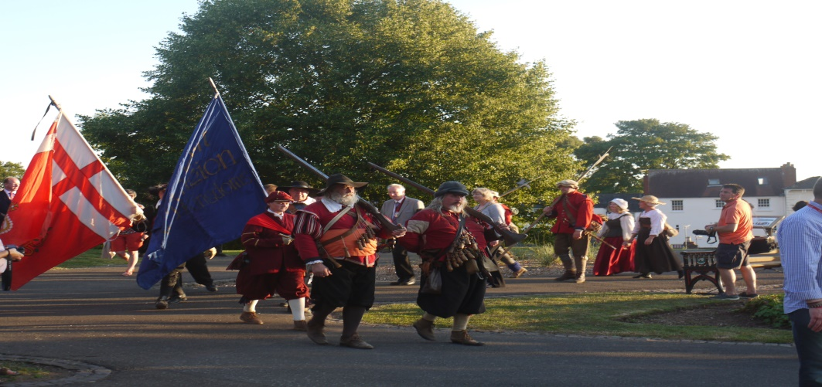

.

**PATRONS OF THE SOCIETY**

**His Grace The Duke of Hamilton ▪ Earl Spencer ▪ Lord Faulkner of Worcester**

**Lord Selkirk of Douglas ▪ Sir Robert Worcester ▪ The Hon. Lady Rosalind Morrison**

**Mr. Henry Berkeley ▪ Ms. Diane Rapaport**

**Professor Ron Hutton • Nigel Adams MP**

**Executive Committee**

**Richard Shaw (Chairman) ▪ Daniel Daniels (Vice Chairman)**

**Geoff Yapp (Hon. Treasurer) ▪ Christine Shaw (Honorary and Membership Secretary)**

**Guy Little (Hon Secretary of the Trustees) ▪ Vaughan Wiltshire**

**Kenneth Potts ▪ Roger Fairman ▪ Brian Bullock ▪ Robbie Porter ▪ Tim Young**

**Trustees**

**Richard Shaw (Chairman) ▪ Guy Little (Hon. Secretary)**

**Jack Randall ▪ Peter Brookes ▪ Christine Shaw ▪ Roger Fairman ▪ Grant Simmonds**

**Ben Humphrey ▪ Geoff Yapp ▪ Daniel Daniels ▪ Vaughan Wiltshire**

**Monument Appeal**

**Lord Richard Faulkner is Patron of the Appeal**

**Black Pear Bulletin Editorial Team**

**Christine Shaw**

**Richard Shaw**

**Tel. 01905 358640**

[**www.thebattleofworcestersociety.org.uk**](http://www.thebattleofworcestersociety.org.uk)